Red text means an important note, Purple Text is code, Dark Green text is referencing the steps for the blank intake templates, highlighted and underlined text links to another portion of the document. All Text between [Start Code ->] and [<- End Code] should be copied verbatim, if you change any text between these two tags you are editing the code itself at your own risk, it is suggested that you do not do this unless you know what you are doing.

Glossary I (Hold Control and Click the Link to go there)

1. Setting Up the File Path in Access for your Templates
2. Create a folder for your template
3. Put your word template in the folder
4. Prepping the Document for Macros

Setting Up the File Path in Access for your Templates

Go to this file path location and put the folder that will contain the tempalte you want to use for Intake (not blank Intake).

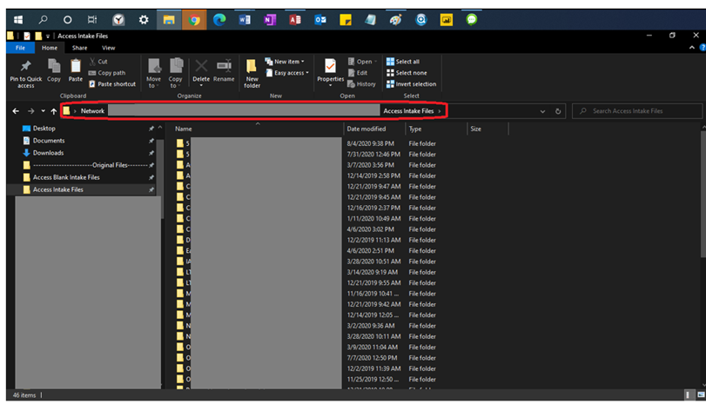

Create a folder for your template

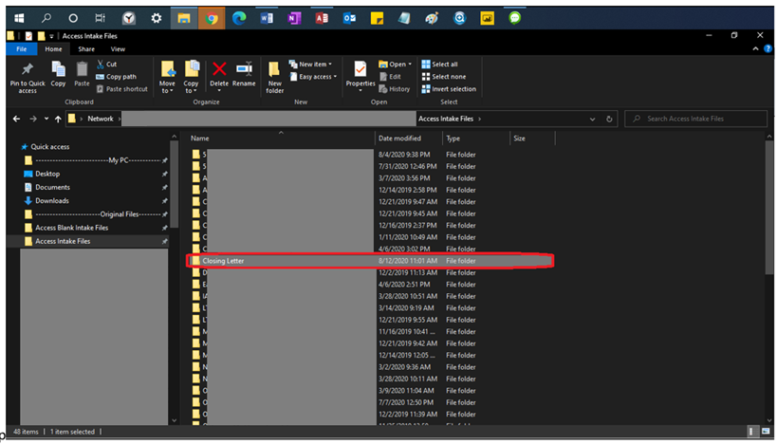

Put your word template in the folder

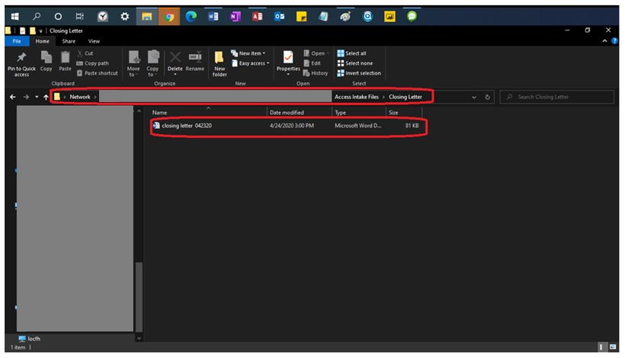

Go into design view in Microsoft Access from within the the Contact Summary Tab

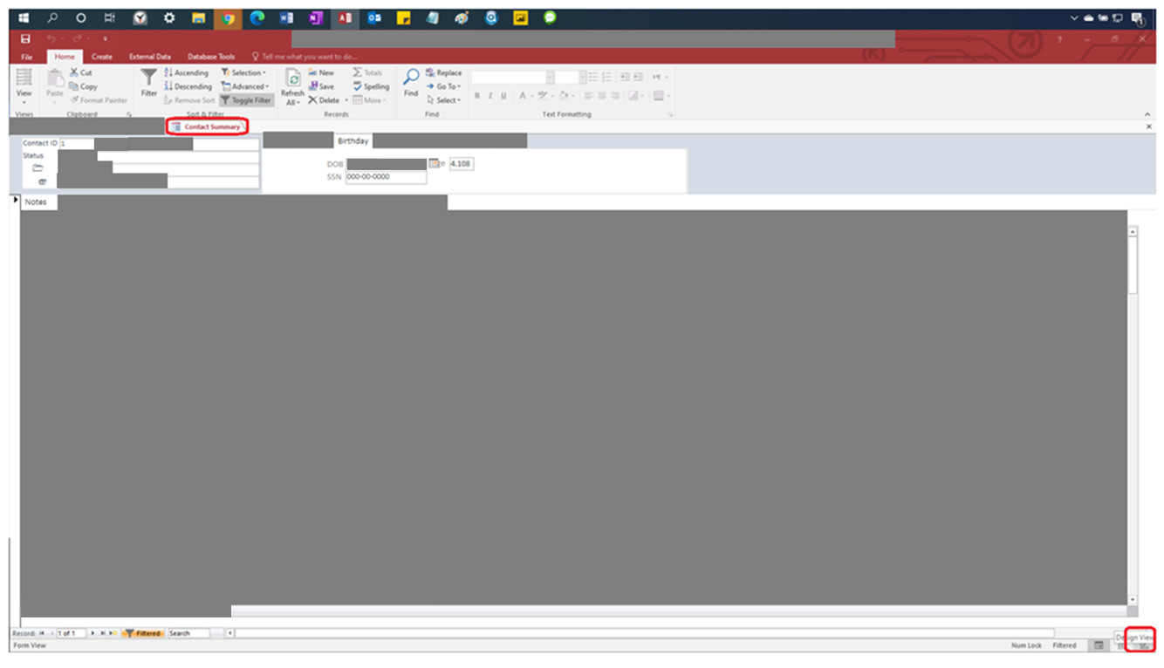

Right Click the dropdown that you want to add the template to, then click the Edit list items… option on the drop. In this case we picked the Templates drop down to add an Edit list item to. We can do this step for the (Blank) Templates drop down as well.

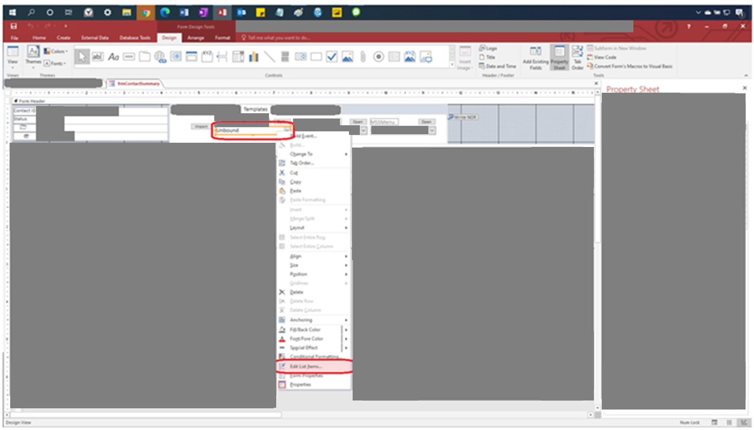

Continue Revision Here

After you’ve clicked “Edit List Item” add the template folder name (the name in the “Create a folder for your template” step) into your list. CONTINUE TO KEEP THIS LIST IN ALPHABETICAL ORDER. This step is same for the (Blank) Templates.

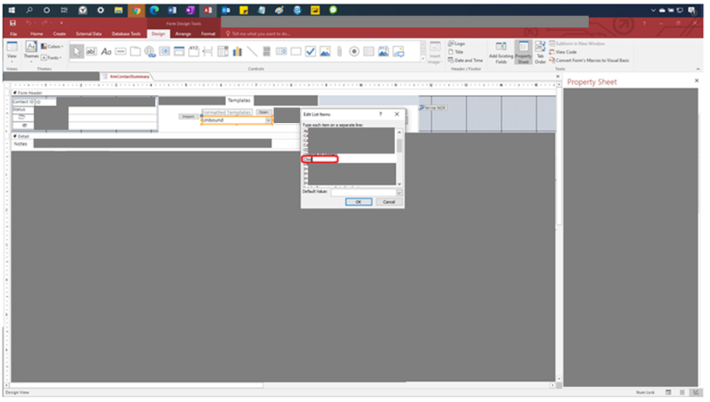

Click the “Database Tools” tab at the top of access and then click “Visual Basic”. This is the same for the (Blank) Templates drop down as well.

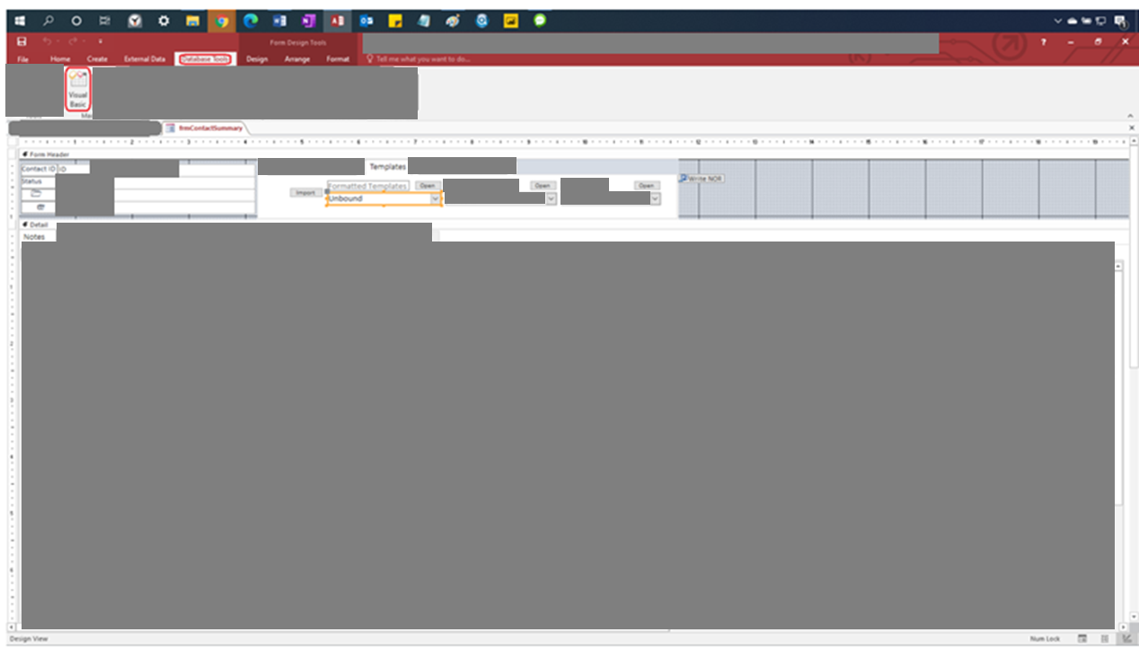

Look for “Microsoft Access Class Objects” from the panel on the left. If the window is not there, then click the “View” tab and then select the “Project Explorer” to view **Microsoft Class Objects**.

Within that panel look for “Form_frm_ContactSummary” object and select it. This step is the same for the (Blank) Templates as well.

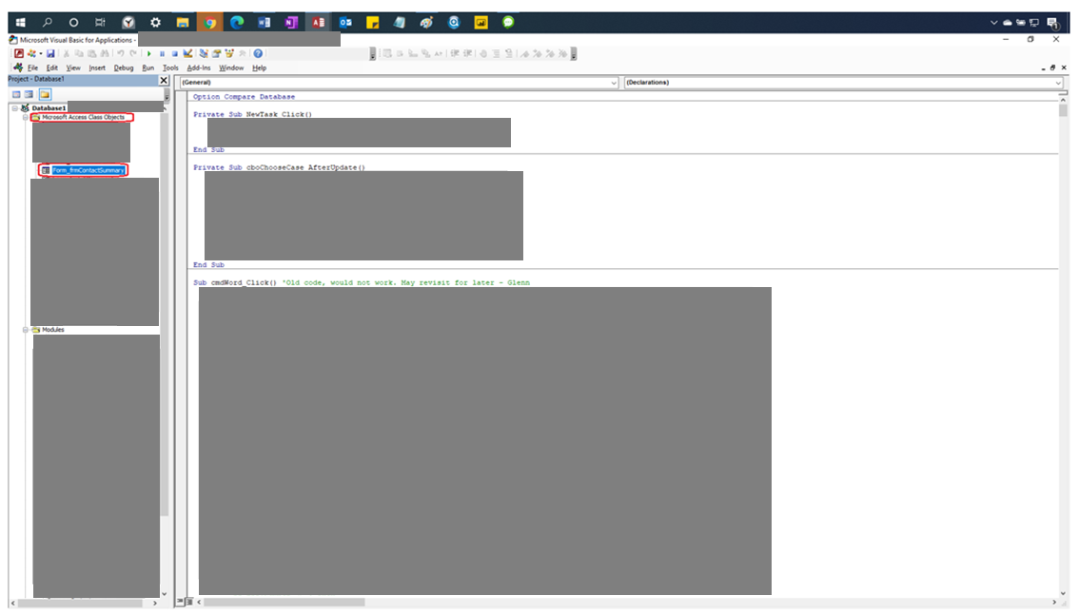

Look for (in the code area on the right) the **Subroutine** called “GetFormSelected()” within the “Form_frm_ContactSummary” object in the **Microsoft Access Class objects** on the left. If you are putting this code in for the (Blank) Templates drop down look for the “SelectBlankIntake()” **subroutine** (on the page itself with the other code) within the “Form_frm_ConactSummary” object (on side bar on the left).

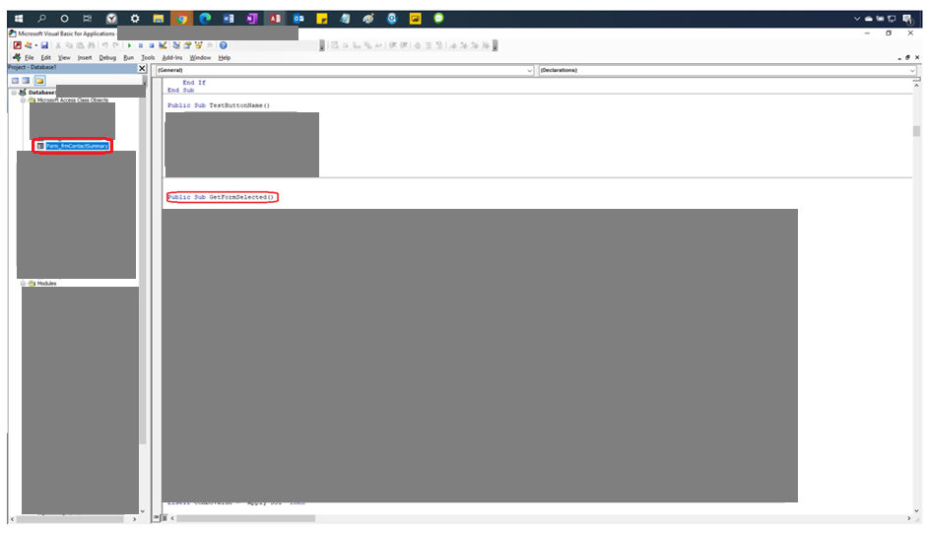

Look at ComboValue = “__________” code when scrolling down the page. Once you find the alphabetized spot for your list item name (The name you typed in After you’ve clicked “Edit List Item” add the template folder name step) put your code here (in the blank red area). In this example “Closing Letter” comes right after “Change of Address” alphabetically. Do this for the (Blank) Templates as well but do so inside the **subroutine** “SelectBlankIntake()” **subroutine** code in the code area (instead of underneath the GetFormSelected() **subroutine** ).

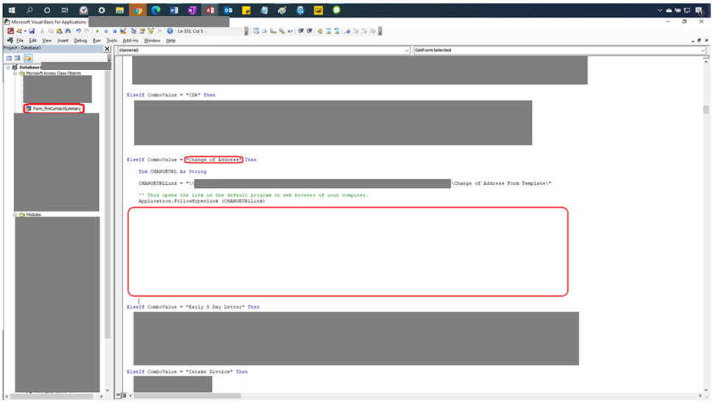

Copy the code in the block below starting with Elseif.

[Start Code ->]

ElseIf ComboValue = “Change of Address” Then

Dim CHANGEURL As String

CHANGEURLLink = “\\[Censored]\Change of Address Form Template\”

‘This opens the link in the default program or web browser on your computer

Application.FollowHyperlink (CHANGEURLLink)

[<- End Code]

Do this for the (Blank) Templates as well but do so inside the **subroutine** “SelectBlankIntake()” inside the code area (instead of underneath the GetFormSelected() **subroutine** code area).

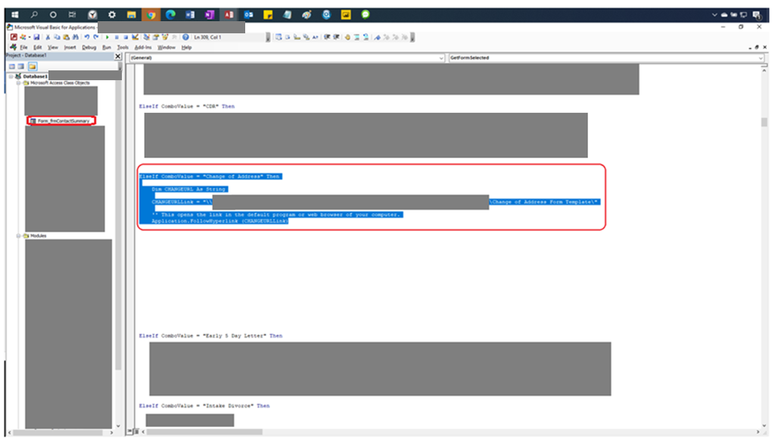

Edit the code below. Set: Combo Value = “(The name you typed in the After you’ve clicked “Edit List Item” add the template folder name step)”

The blue circles in the image are part of the variable names. All three blue circle areas in the image (before the characters “URL” with no spaces between the new code and the text “URL”) are the same with the other circles within this section, but are unique from all other variable names in other sections of the code.

The purple line is the beginning of the file path to the folder you created. In this instance the red line is the only part different from the copied code’s file path. The red part is the name of the folder you created in the Create a folder for your template step. Do this for the blank templates as well but do so inside the **subroutine** “SelectBlankIntake()” in the code area in it’s alphabetized spot (instead of under the GetFormSelected() **subroutine** code area).

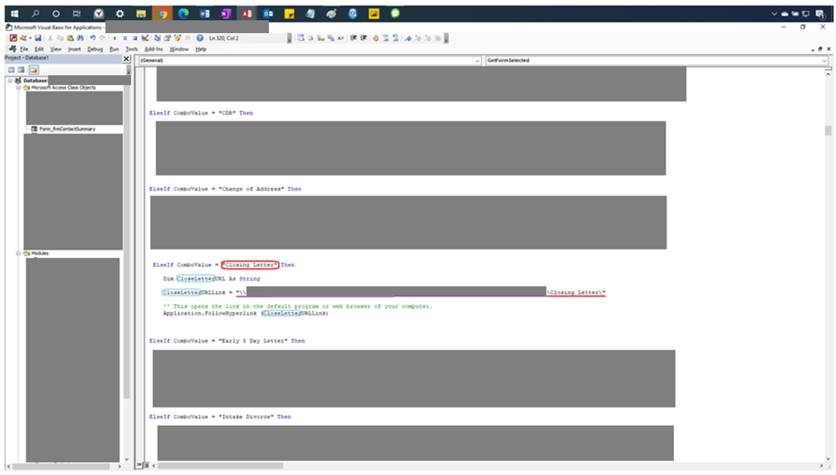

Switch back to form view within Access for testing the code we installed.

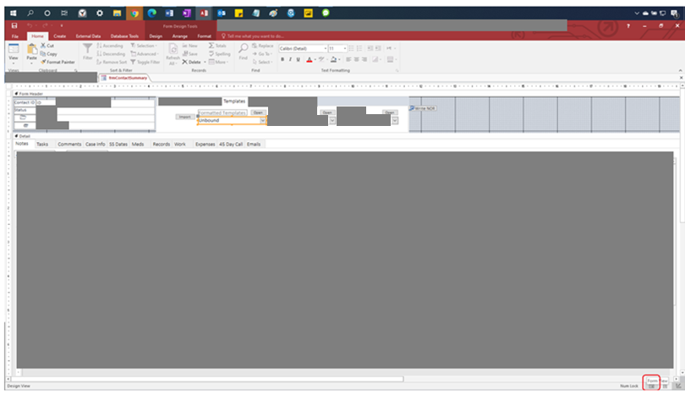

Go to the Templates subtab and select the drop down you added the closing letter to (Formatted Templates, (Blank) Templates & MSSMenu).

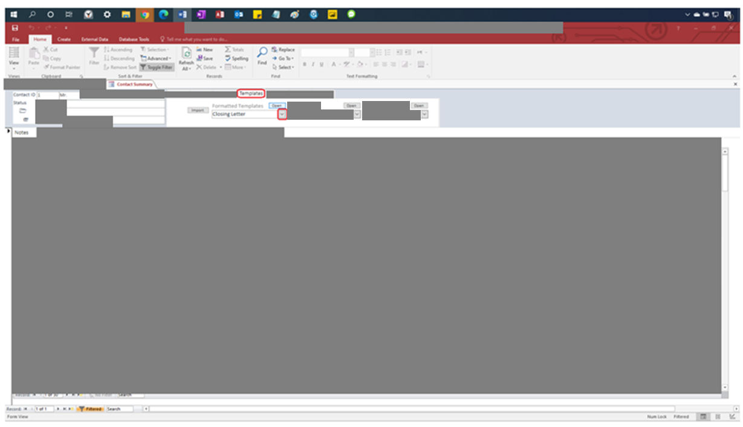

Select Closing Letter from the drop down list and then select open.

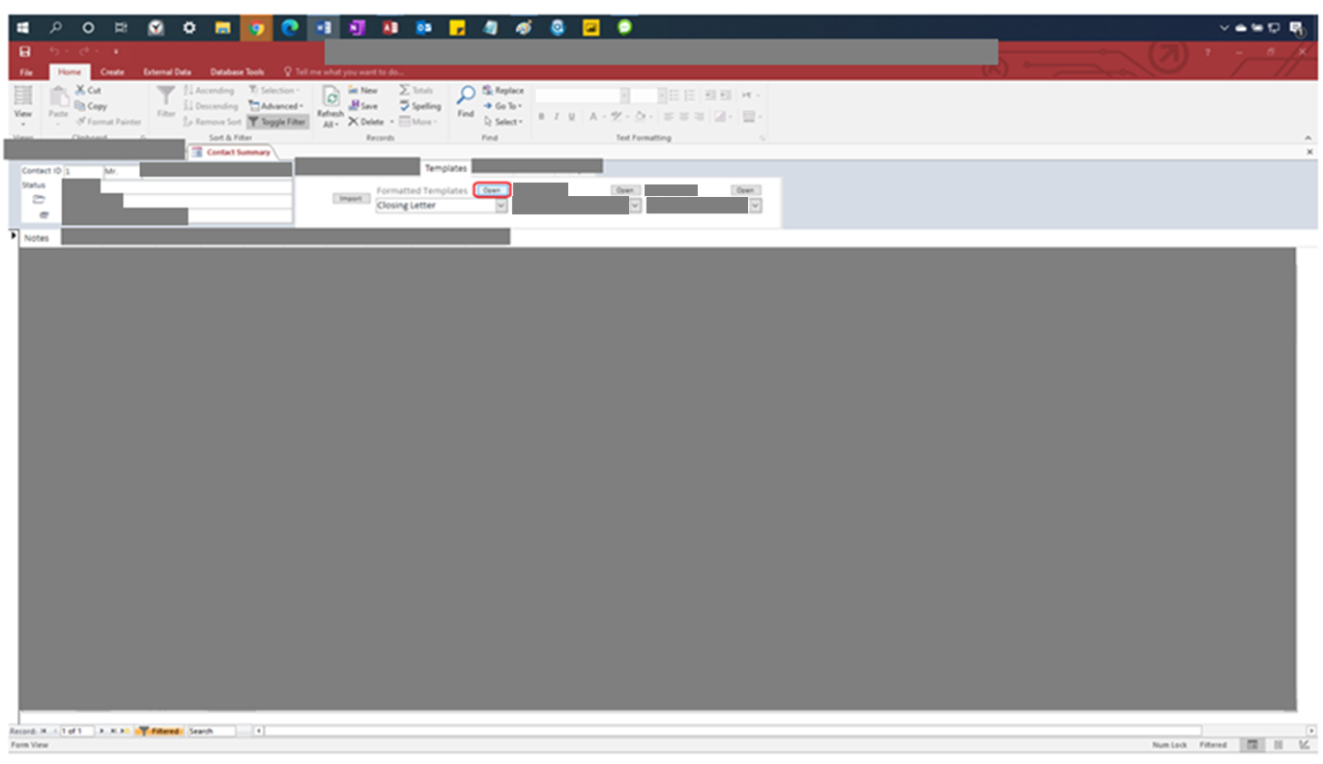

Check the file path of the window that opens up. If it matches the file path of folder you put in the Put your word template in the folder step then the code was changed correctly. Also see if your template is in this folder as well.

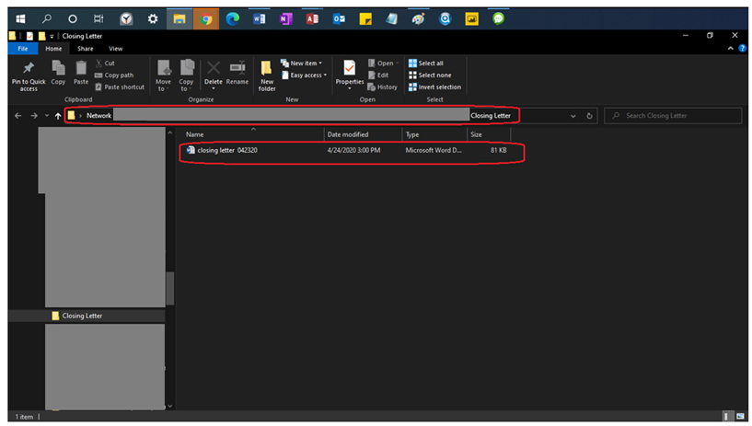

On a final note, when you need to add the drop down item to the other (Blank) Templates drop down you need to put the folder in this location (which is censored for distribution).

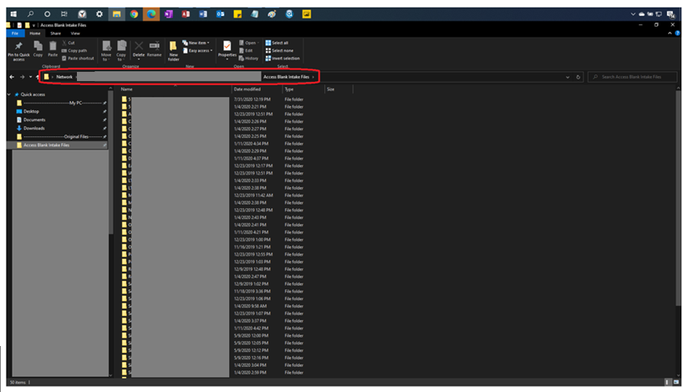

Prepping the Document for Macros

Save a blank new word document as a Macro Enabled Template. This format is necessary to work with these templates. You will have to exit the current document and then right click this template and select open to save your changes. Do this now so you won’t lose progress.

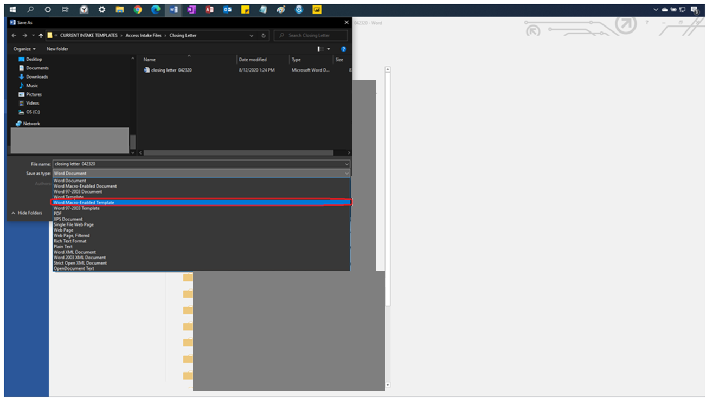

RIGHT CLICK YOUR FILE and SELECT OPEN. IF YOU DO NOT DO THIS WHEN YOU OPEN A MACRO ENABLED FILE ALL YOUR CHANGES FROM THIS POINT ONWARD CANNOT BE SAVED.

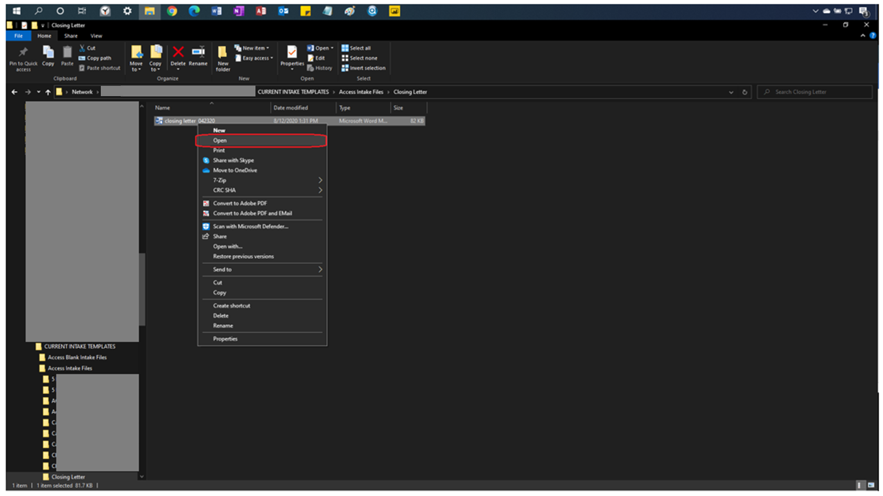

To turn on the developer’s tab first select the file tab.

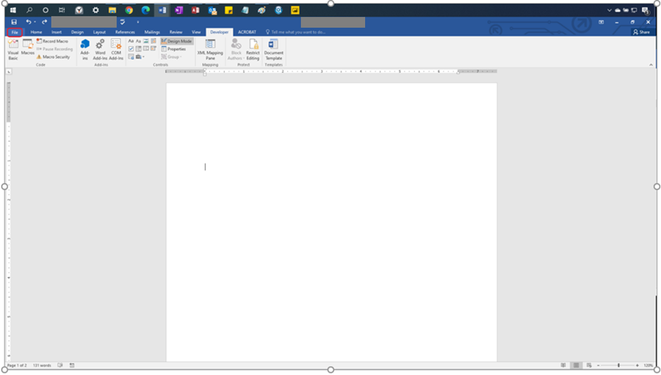

Select the Options tab

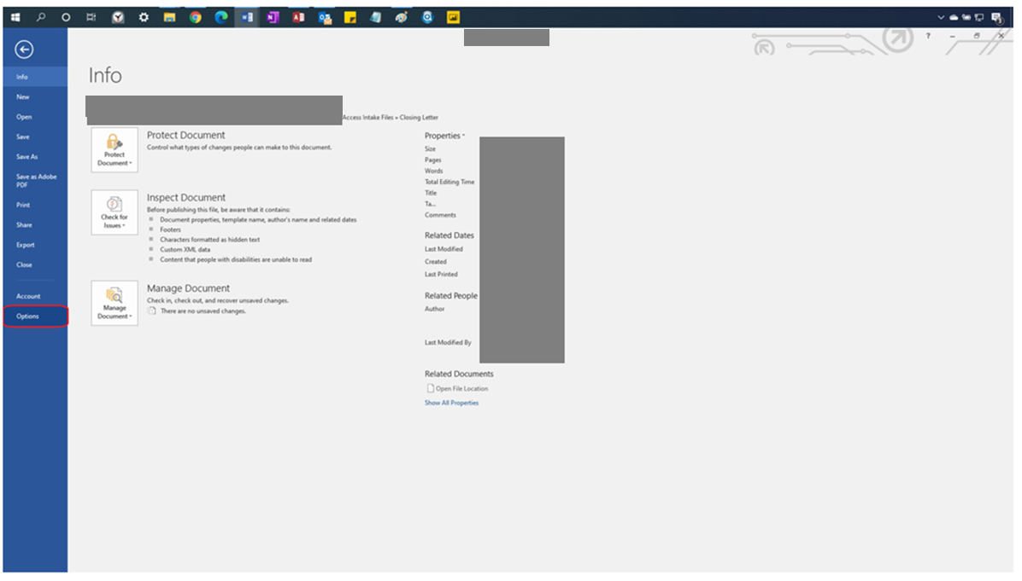

Select Customize Ribbon

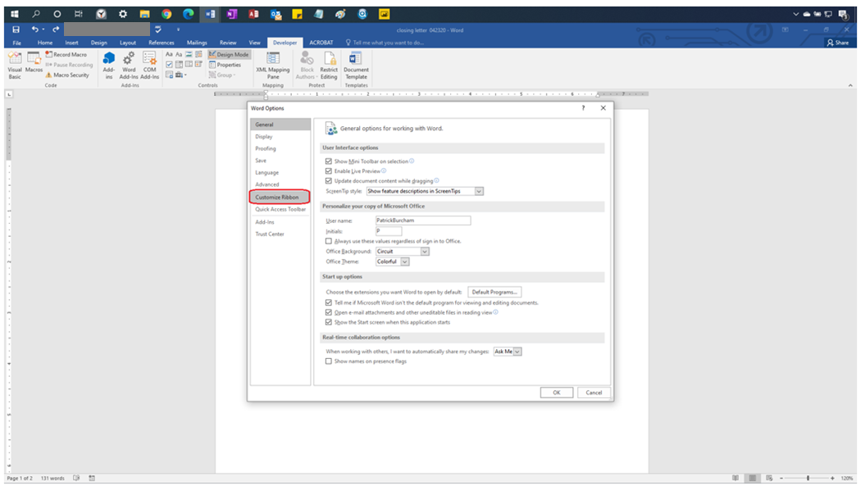

Select Developer. This turns on the developer tab in the Microsoft Word.

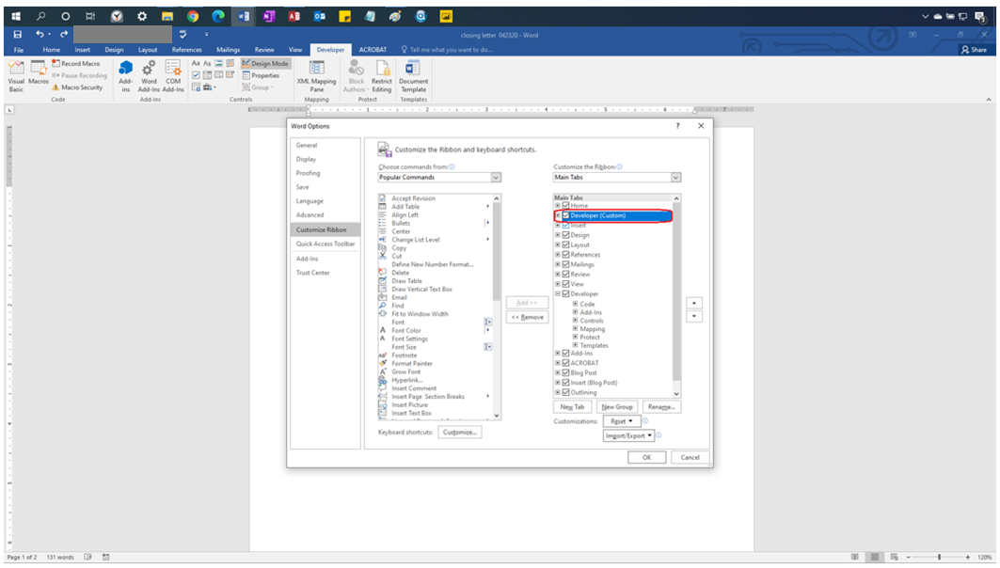

Adding Fillable Fields to your Templates

From this point onward, if you’re using a Letter Address without an Apartment or Suite Number then go to the pink text, if you’re using a Letter Address with an Apartment or Suite Number then go to the blue text, if you’re using an [Censored] Address go to the green text, if you’re using a [Censored]Address go to the yellow text. If looking at a Blank Intake Template then use gray/silver text. All Purple text for these four areas onward is code in between [Start Code ->] and [<- End Code] should be copied verbatim, if you change any text between these two tags you are editing the code itself at your own risk, it is suggested that you do not do this unless you know what you are doing. Red Text from here on is still important notes.

Glossary II (Hold Control and Click the link to go there)

1. Letter Address (no apartment or suite number):
2. What you should Name your Fields
3. Creating and Naming the Button
4. Creating and Naming the Button
5. Pasting the Code
6. Editing the Code
7. Letter Address (with apartment or suite number):
8. What You Should Name Your Fields
9. Creating and Naming the Button
10. Pasting the Code
11. Editing the Code
12. [Censored] Addresses:
13. What You Should Name Your Fields
14. Creating and Naming the Button
15. Pasting the Code
16. Editing the Code
17. [Censored]Addresses:
18. What You Should Name Your Fields
19. Creating and Naming Buttons
20. Pasting the Code
21. Editing the Code
22. Blank Intake Forms (No Auto Filling):
23. Creating and Naming Buttons
24. Pasting the Code
25. Editing the Code
26. Adding Tags to Access:
27. Checking the Access’s Field Name

Letter Address (no apartment or suite number)

Before editing you need to save your document as a macro enabled template. Then when you want to edit the document in the future you right click the document and select open.

Click the Developer Tab, then Design Mode, then the gray chest, then go to legacy forms and select Text Form Field. Do this a total of 8 Times (for this form). These will be the fill in areas that have data come from Access

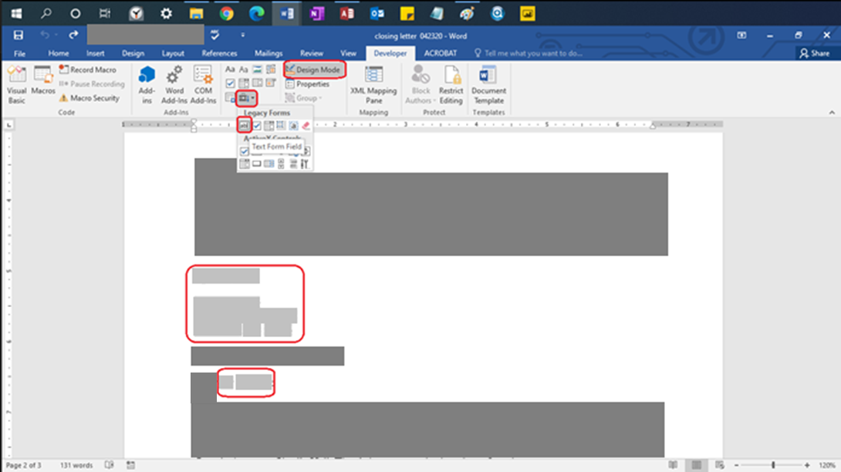

Right Click the field and select properties

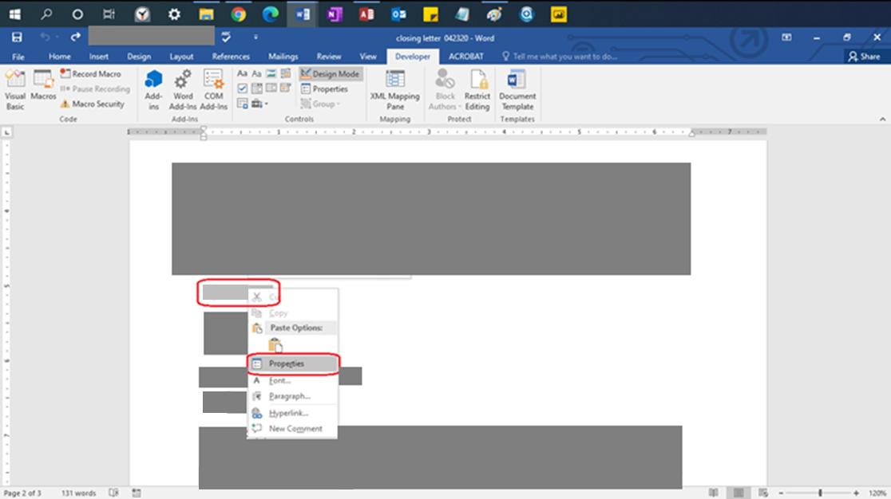

Insert the name of the Field in the blank under “Bookmark:”. This is what is referred to in the code when you try to reference that Microsoft Word field. In this picture the field is named CurrentDateTag

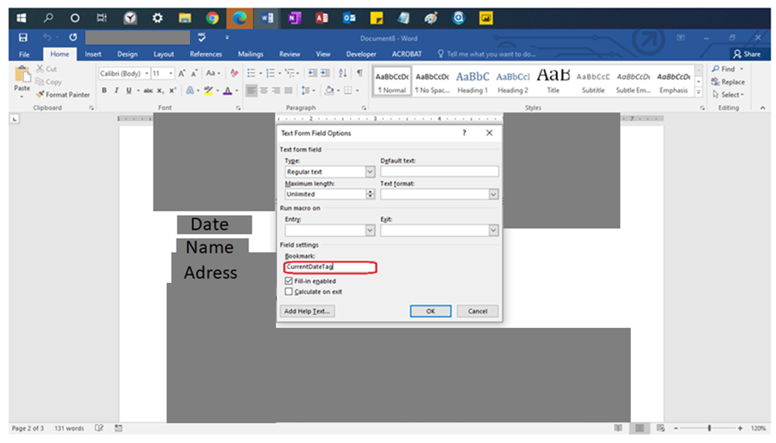

What You Should Name Your Microsoft Word Fields

CurrentDateTag (This date is generated when save button is pressed, this goes at the top)

FormNameTag (Name of the client)

Address1 (Address of the client)

City2 (City of the client)

StateProvince2 (State/Province of the client)

ZipPostal2 (Zip Postal of the client)

Salute (Mr./Mrs./Ms.)

LastNameTag (Last name of the client)

Layout of your Microsoft Word fields:

CurrentDateTag

<Empty Row>

FormNameTag

Address1

City2 <one space> StateProvince2 <one space> ZipPostal2

<Row>

Salute <one space> LastNameTag

Creating and Naming the Button

Make sure the first page of the document is blank.

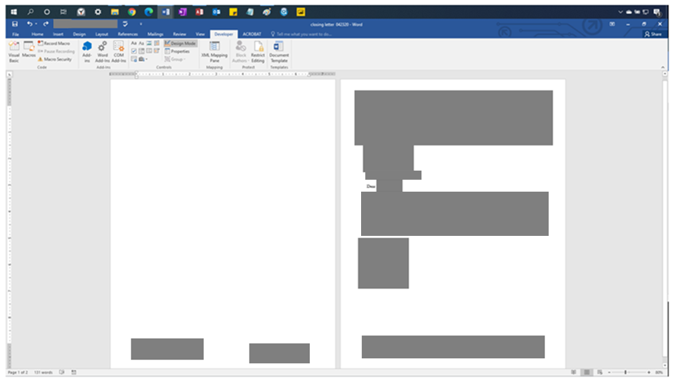

After putting your cursor in the first page, select the Developer tab. Then select the chest in the Controls group. Then select the Command Button in the Active X Controls.

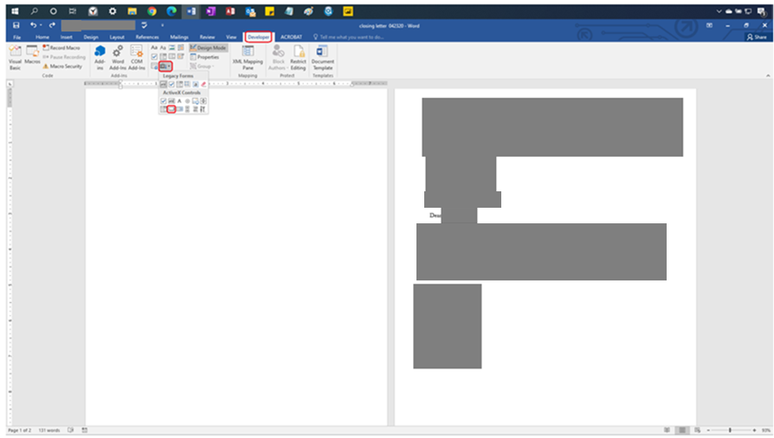

Position the button you create to be this size and in this position. The button should be completely to the left of the page margin in case it doesn’t delete properly when the code is run.

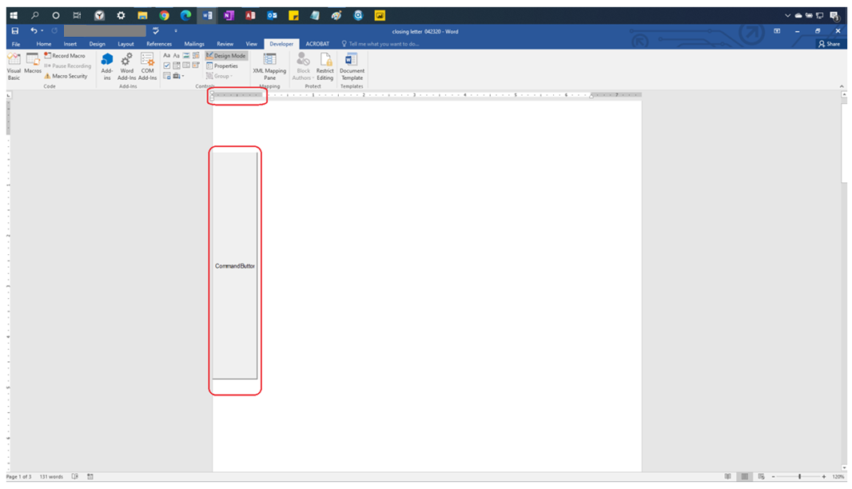

Right Click the Command Button after clicking Design Mode, in the Developer Tag and the select properties

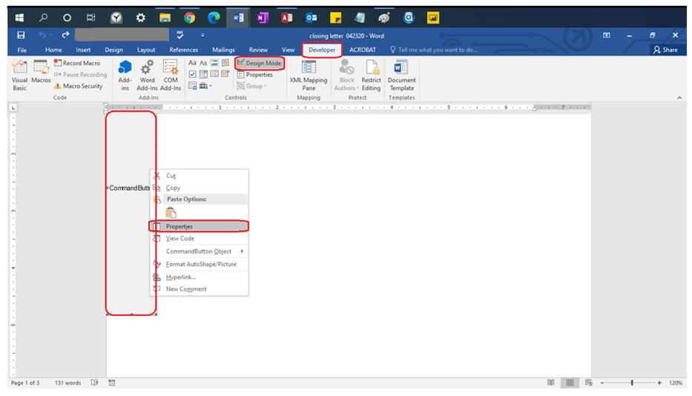

Change the name of the button from **CommandButton1** to **CommandButtonSave**

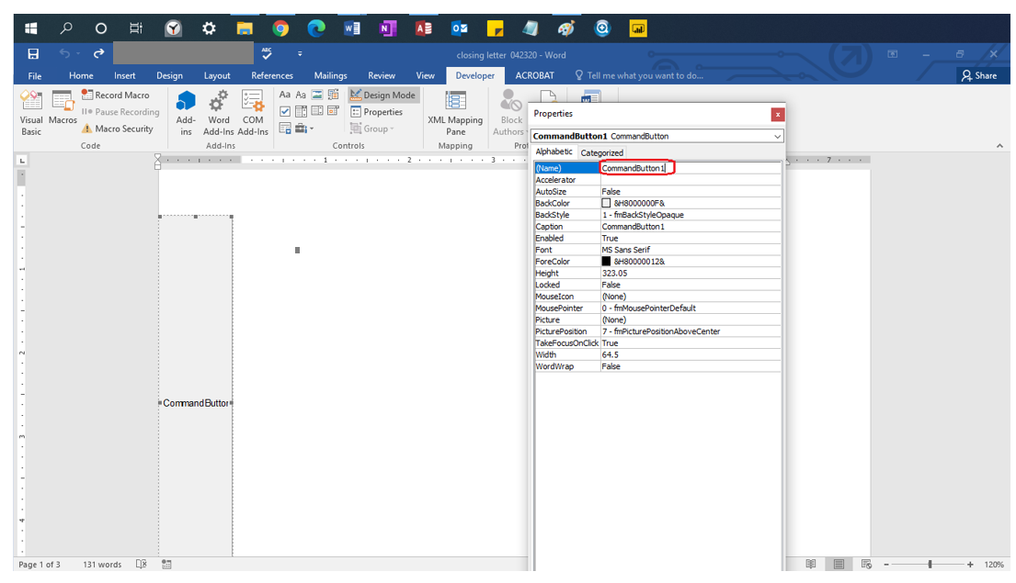

Right Click the Design View in the developer tab, then right click the button and select “View Code”

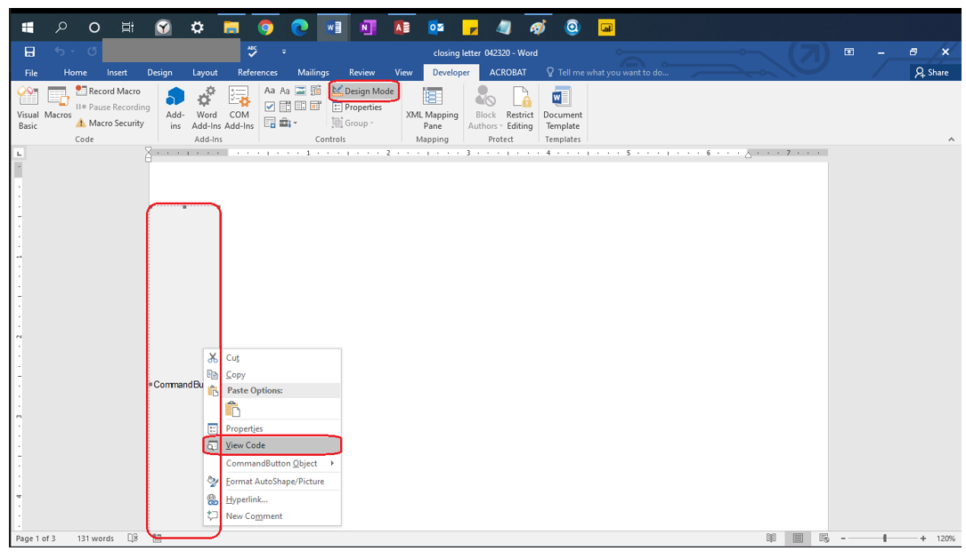

You will see the words “Private Sub” or “Public Sub” listed with a **subroutine** name (green underline) (the parenthesis are necessary), the end of the **subroutine** is the words “End Sub”. IF YOU DO NOT PASTE THE NEXT SECTION’S CODE IN BETWEEN THESE TWO LINES of Code (You can space them out by putting your cursor between them and pressing enter) IT WILL NOT WORK. DO NOT DELETE THESE LINES OF CODE. EVEN IF YOU REPLACED THE CODE WITH THE SAME VERBATIM TEXT, IT WILL NOT WORK. IF YOU DID NOT RENAME YOUR BUTTON TO CommandButtonSave IN THE PREVIOUS STEP YOUR CODE WILL NOT WORK, EVEN IF PASTED CORRECTLY.

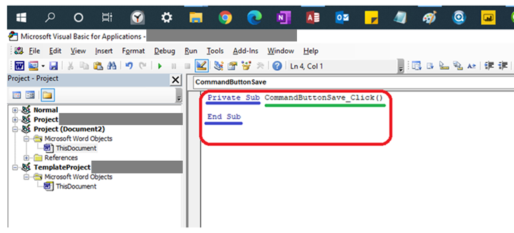

Pasting the Code

Paste the following purple text code (any other color text is not code to be pasted) into the Button’s Code in between the **Subroutine**’s Name and the words “End Sub” (See previous step if you’re confused about what the **subroutine** is)

[Start Code ->]

'Set Microsoft Word Object

Set WordObj = GetObject(, "Word.Application")

'Create and store variables

Dim varPCName As String

Dim varDate As String

varPCName = FormFields("FormNameTag").Result

'Test to see if the information has been imported into Access, if blank then do not save the document

If varPCName = "" Then

MsgBox "You need to import the information from Access before Saving the Document "

End

Else

ActiveDocument.FormFields("CurrentDateTag").Result = Format(Date$, "mmmm d, yyyy")

Me.CommandButtonSave.Height = 1

Me.CommandButtonSave.Width = 1

Selection.GoTo wdGoToPage, wdGoToAbsolute, 1

ActiveDocument.Bookmarks("\page").Range.Delete

End If

'This is for the [Censored](which is to be imported from the Access Database)

'Dim varFieldTest As String

'

'varFieldTest = ActiveDocument.FormFields("MailingAddress2").Result

'

'If varFieldTest = "" Then

'

'ActiveDocument.FormFields("MailingAddress2").Delete

'

'ActiveDocument.FormFields("MailCity").Delete

'ActiveDocument.FormFields("MailState").Delete

'ActiveDocument.FormFields("MailZip").Delete

'ActiveDocument.FormFields("Comma2").Result = ","

'

'ActiveDocument.FormFields("Comma").Delete

'

'

'End If

'Check to see if the Second Address is there, if there is no second address then delete the field box

'where the Second Address would be stored

'Commented Out only for the tutorial

'Dim varAddressTest As String

'

'varAddressTest = ActiveDocument.FormFields("[Censored]").Result

'

'If varAddressTest = "" Then

'

'ActiveDocument.FormFields("[Censored]").Delete

'Move the City, State and Address up by one line by

'deleting the 8th paragraph (empty paragraph that took

'the place of the second address once it was deleted)

ActiveDocument.Paragraphs(8).Range.Select

Selection.Delete

'Else was commented out for the turorial

'Else

'Do nothing if the [Censored]is not empty

'End If was commented out for the tutorial

'End If

'Get variables for the file name

varName = ActiveDocument.FormFields("FormNameTag").Result

varDate = Date$

'Save the File with the varible names

WordObj.ActiveDocument.SaveAs "\\[Censored]\Closing Letter Forms\Closing Letter Form, " & varName & ", " & varDate & ".docx"

[<- End Code]

Editing the Code

Change the file path for saving the file to the Folder where you want to save your templates. This this case you need to change the red parts of the code (listed here). You can find this code by searching “WordObj.ActiveDocument.SaveAs”

'Save the File with the variable names

WordObj.ActiveDocument.SaveAs "\\[Censored]\Access Template Forms\[Censored]" & varName & ", " & varDate & ".docx"

The changes you need to make are listed in blue (the changes need to be to the file path that you want to save the file to)

'Save the File with the variable names

WordObj.ActiveDocument.SaveAs "\\[Censored]\Access Template Forms\[Censored] " & varName & ", " & varDate & ".docx"

Letter Address (with Apartment or Suite Number)

**Before editing you need to save your document as a macro enabled template. Then when you want to edit the document in the future you right click the document and select open if you do not do this your changes cannot be saved.**

Click the Developer Tab, then the gray chest, then go to legacy forms and select Text Form Field. Do this a total of 14 Times (for this form). These will be the fill in areas that have data pushed from Access

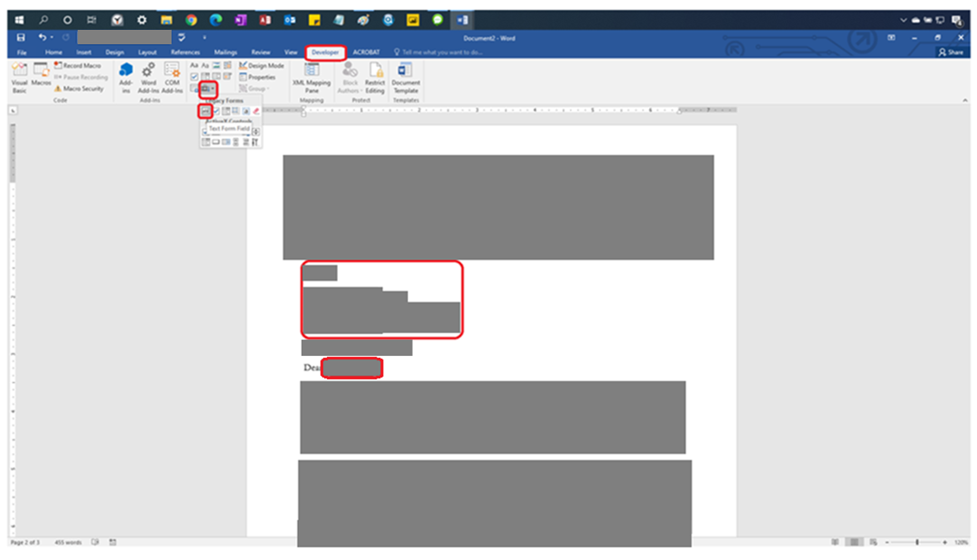

Right Click the field and select properties

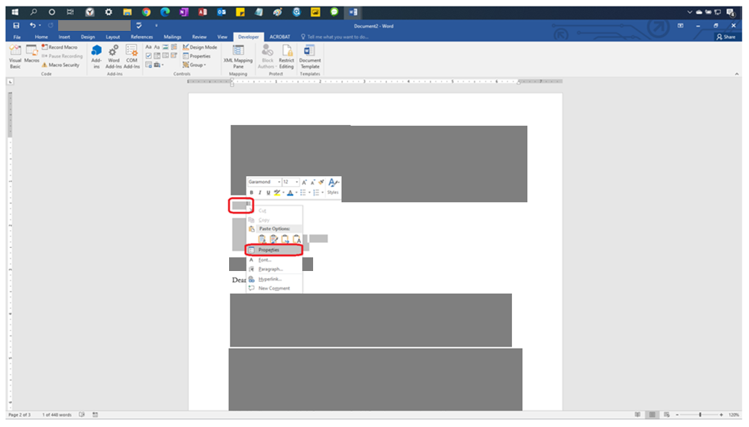

Insert the name of the Field in the blank under “Bookmark:”. This is what is referred to in the code when you try to reference that field. In this picture the field is named CurrentDateTag

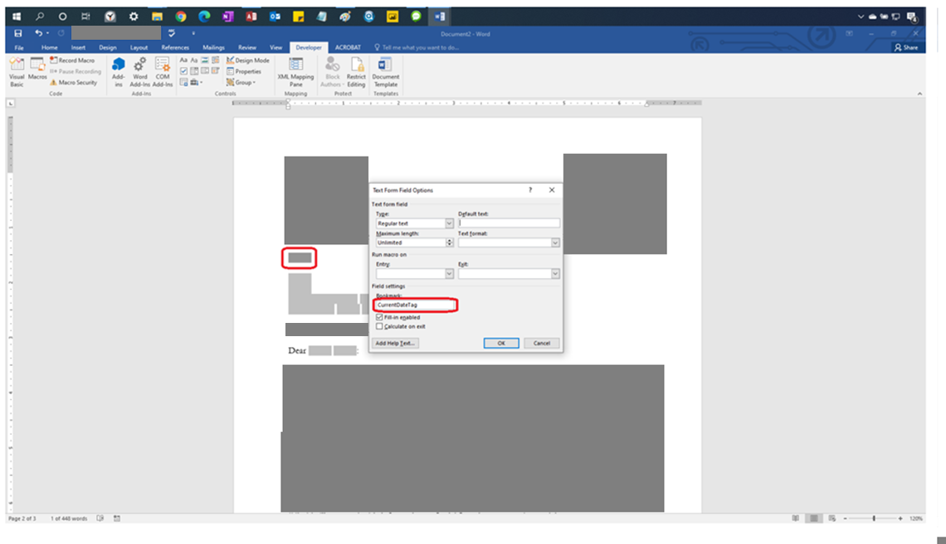

This is what the address layout of text fields looks like for a form

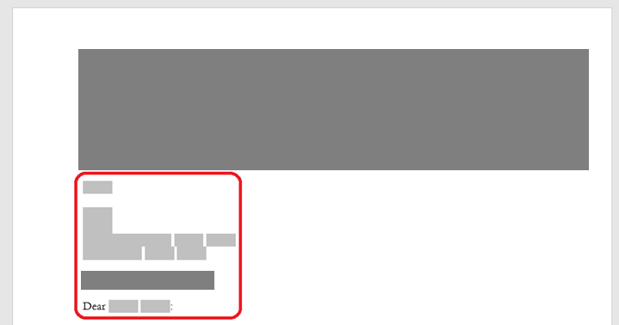

What You Should Name Your Fields (matches above picture layout):

CurrentDateTag

<Emtpy Row>

FormNameTag

Address1

Address2<No space>City2<No space>Comma<One space>StateProvince2<One Space>ZipPostal2

City<No space> Comma2<One space>StateProvince<One space>ZipPostal

Salute<One Space>LastNameTag

Creating and Naming Button

Make sure the first page of the document is blank.

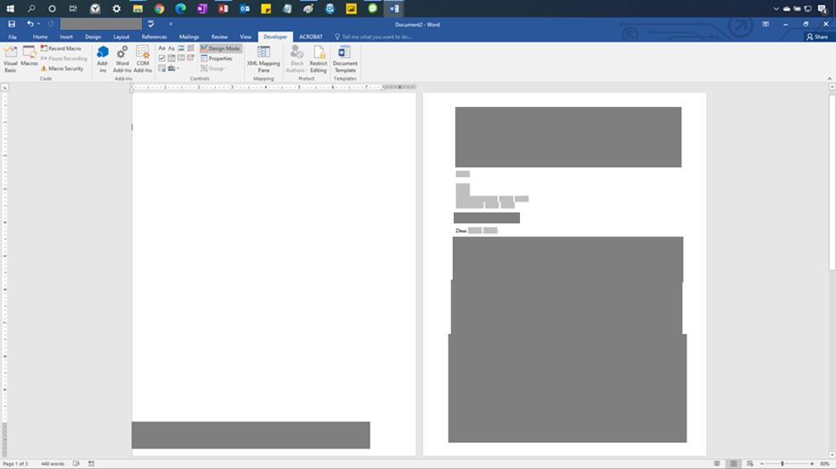

After putting your cursor in the first page, select the Developer tab. Then select the chest in the Controls group. Then select the Command Button in the Active X Controls.

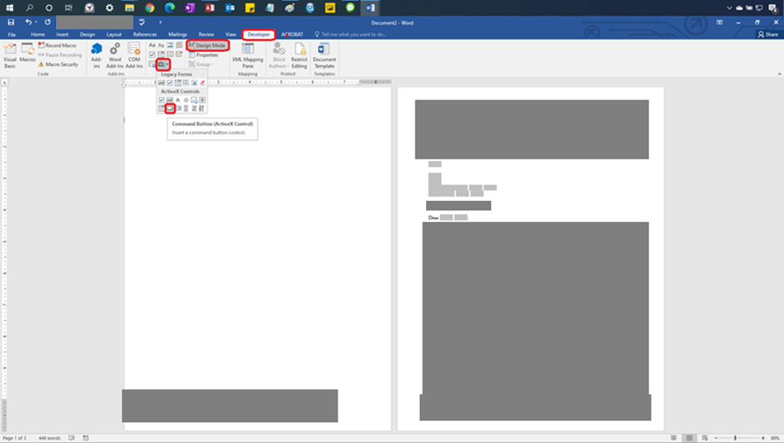

Position the button you create to be this size and in this position. The button should be completely to the left of the page margin in case it doesn’t delete properly when the code is run.

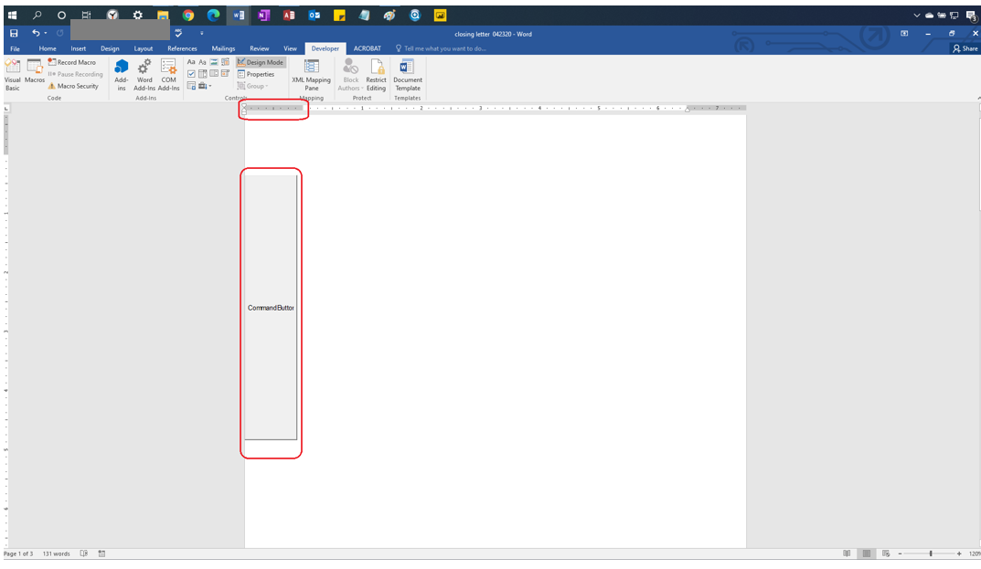

Right Click the Command Button after clicking Design Mode, in the Developer Tag and the select properties

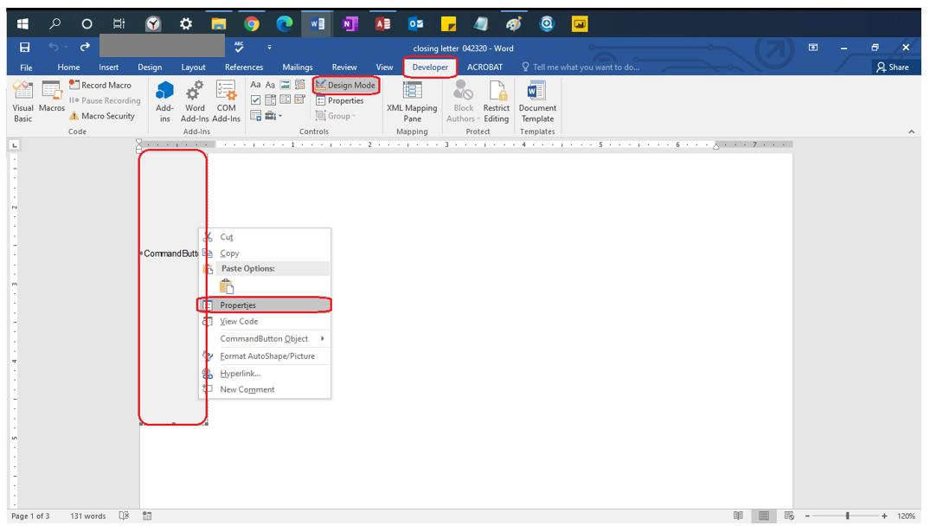

Change the name of the button from **CommandButton1** to **CommandButtonSave**

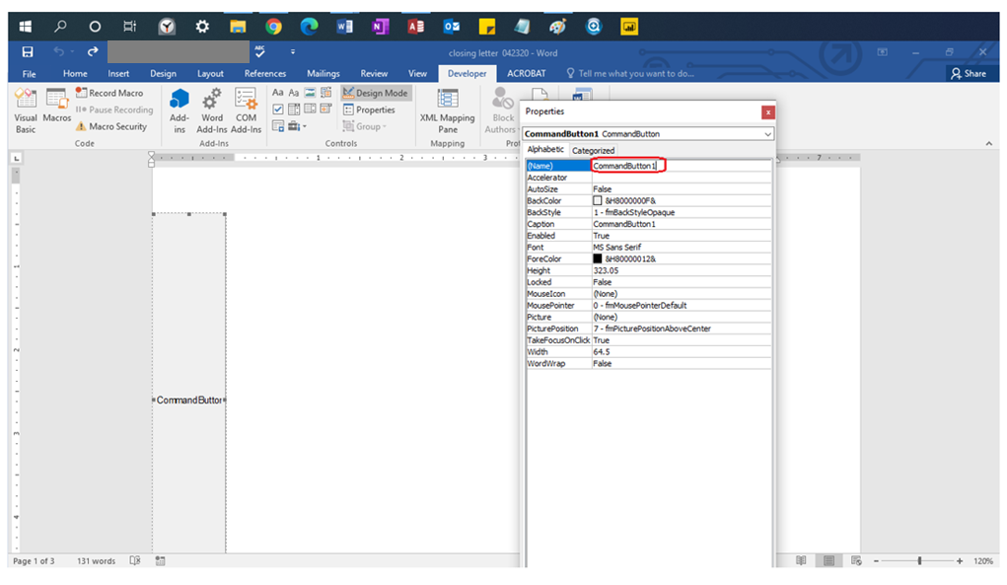

Right Click the Design View in the developer tab, then right click the button and select “View Code”

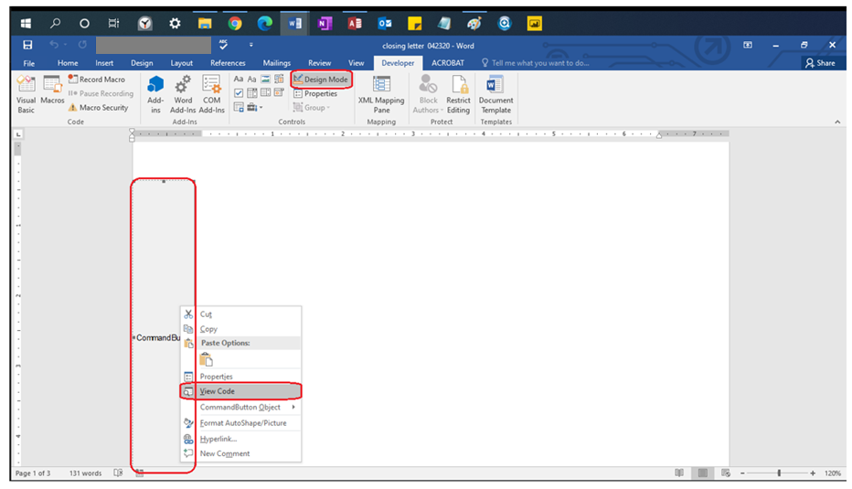

You will see the words “Private Sub” or “Public Sub” listed with a **subroutine** name (green underline) (the parenthesis are necessary), the end of the **subroutine** is the words “End Sub”. IF YOU DO NOT PASTE THE NEXT SECTION’S CODE IN BETWEEN THESE TWO LINES of Code (You can space them out by putting your cursor between them and pressing enter) IT WILL NOT WORK. DO NOT DELETE THESE LINES OF CODE. EVEN IF YOU REPLACED THE CODE WITH THE SAME VERBATIM TEXT, IT WILL NOT WORK. IF YOU DID NOT RENAME YOUR BUTTON TO CommandButtonSave IN THE PREVIOUS STEP YOUR CODE WILL NOT WORK, EVEN IF PASTED CORRECTLY.

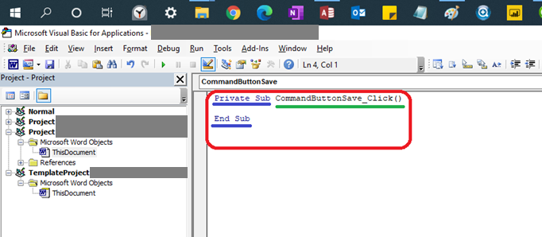

Pasting the Code

Paste the following purple text code into the Button’s Code in between the **Subroutine**’s Name and the words “End Sub” (See previous step if you’re confused about what the **subroutine** is)

[Start Code ->]

'Set Microsoft Word Object

Set WordObj = GetObject(, "Word.Application")

Dim varPCName As String

Dim varDate As String

varPCName = FormFields("FormNameTag").Result

'Test to see if the information has been imported into Access, if blank then do not save the document

If varPCName = "" Then

MsgBox "You need to import the information from Access before Saving the Document "

End

Else

ActiveDocument.FormFields("CurrentDateTag").Result = Format(Date$, "mmmm d, yyyy")

Me.CommandButtonSave.Height = 1

Me.CommandButtonSave.Width = 1

'Had to be commented out for some unknown reason

'Selection.GoTo wdGoToPage, wdGoToAbsolute, 1

ActiveDocument.Bookmarks("\page").Range.Delete

End If

Dim varName As String

varName = ActiveDocument.FormFields("FormNameTag").Result

varDate = Date$

WordObj.ActiveDocument.SaveAs "\\[Censored] " & varName & ", " & varDate & ".docx"

Dim varFieldTest As String

varFieldTest = ActiveDocument.FormFields("Address2").Result

If varFieldTest = "" Then

ActiveDocument.FormFields("Address2").Delete

ActiveDocument.FormFields("City").Delete

ActiveDocument.FormFields("StateProvince").Delete

ActiveDocument.FormFields("ZipPostal").Delete

ActiveDocument.FormFields("Comma").Result = ", "

ActiveDocument.FormFields("Comma2").Delete

Else

ActiveDocument.FormFields("City2").Delete

ActiveDocument.FormFields("StateProvince2").Delete

ActiveDocument.FormFields("ZipPostal2").Delete

ActiveDocument.FormFields("Comma2").Result = ", "

ActiveDocument.FormFields("Comma").Delete

End If

[<- End Code]

Editing the Code

Change the file path for saving the file to the Folder where you want to save your templates. This this case you need to change the red parts of this code (listed here). You can find this code by searching “WordObj.ActiveDocument.SaveAs”.

'Save the File with the variable names

WordObj.ActiveDocument.SaveAs "\\[Censored]\Access Template Forms\[Censored]" & varName & ", " & varDate & ".docx"

The changes are listed in blue (Change this to the file path where you want to save your templates)

'Save the File with the variable names

WordObj.ActiveDocument.SaveAs "\\[Censored]\Access Template Forms\[Censored] " & varName & ", " & varDate & ".docx"

[Censored]Addresses

Before editing you need to save your document as a macro enabled template. Then when you want to edit the document in the future you right click the document and select open.

Click the Developer Tab, then Design Mode, then the gray chest, then go to legacy forms and select Text Form Field. Do this a total of 12 Times (for this form). These will be the fill in areas that have data come from Access

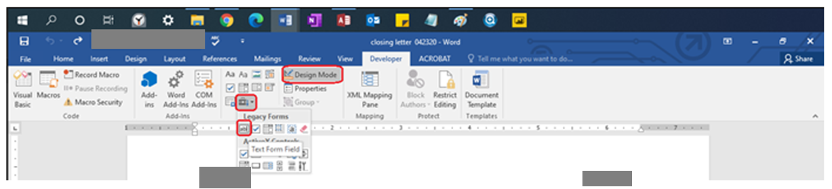

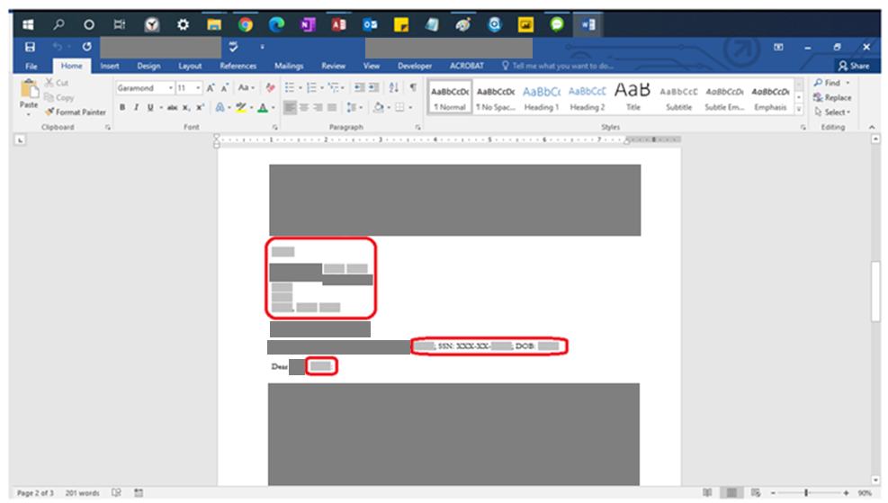

Right Click the field and select properties

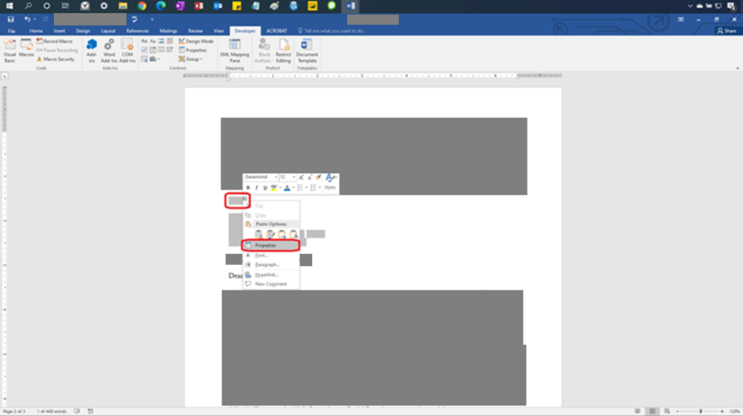

Insert the name of the Field in the blank under “Bookmark:”. This is what is referred to in the code when you try to reference that field. In this picture the field is named CurrentDateTag

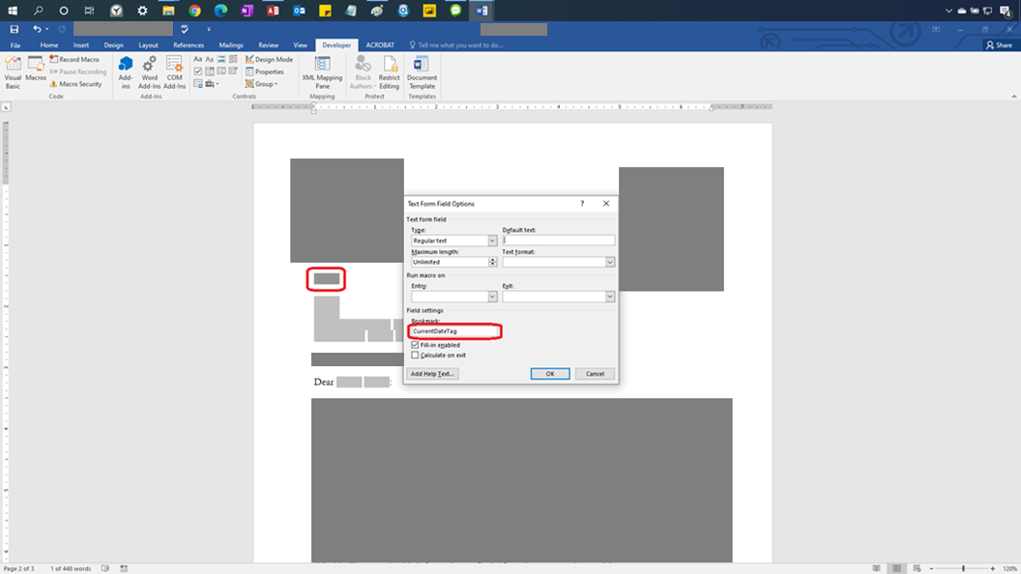

This is what the address layout of text fields looks like for a form

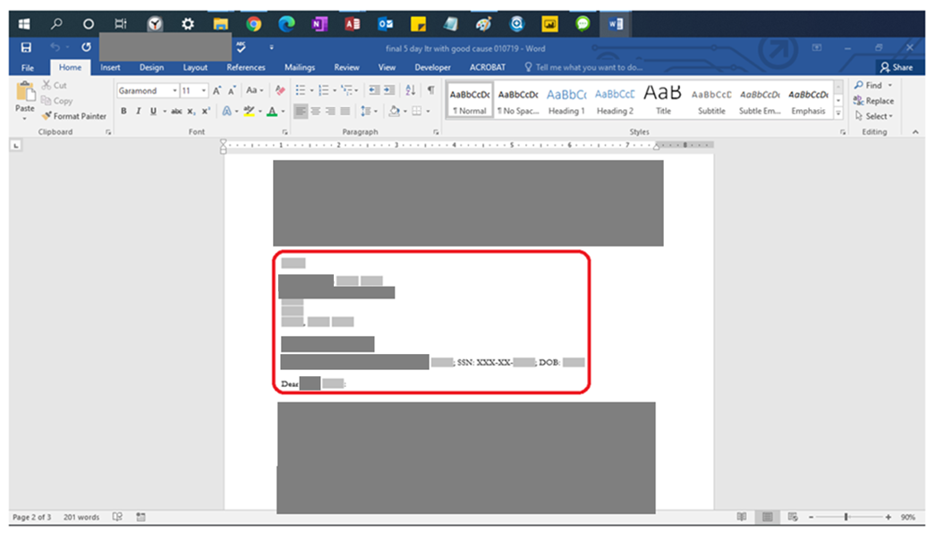

What you should name your fields (matches above picture layout):

CurrentDateTag

[Censored]<One space> [Censored]

[Censored]

[Censored]StreetAddressOne

[Censored]StreetAddressTwo

[Censored]City,<One space> [Censored]State<One space> [Censored]Zip

FormNameTag, SSN4Tag, DOBBoxTag

[Censored]

Creating and Naming Button

Make sure the first page of the document is blank.

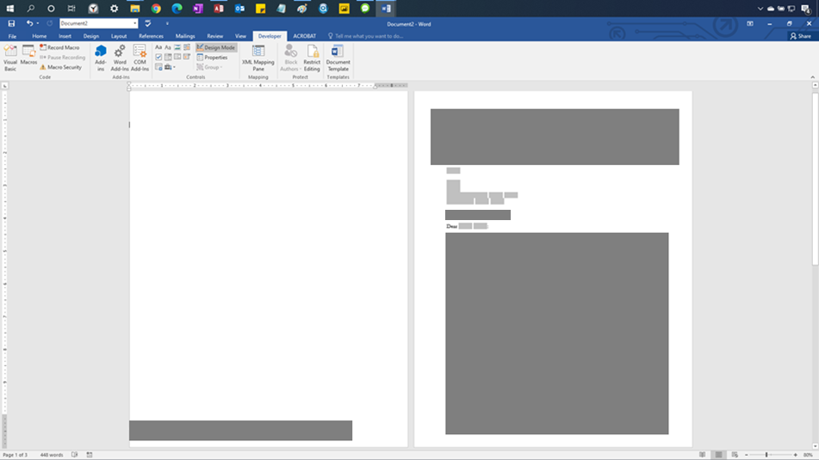

After putting your cursor in the first page, select the Developer tab. Then select the chest in the Controls group. Then select the Command Button in the Active X Controls.

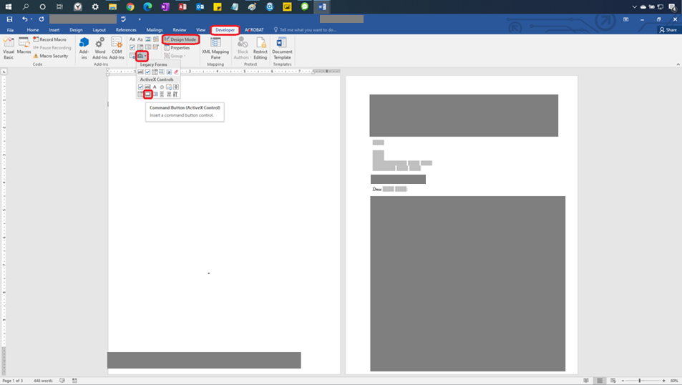

Position the button you create to be this size and in this position. The button should be completely to the left of the page margin in case it doesn’t delete properly when the code is run.

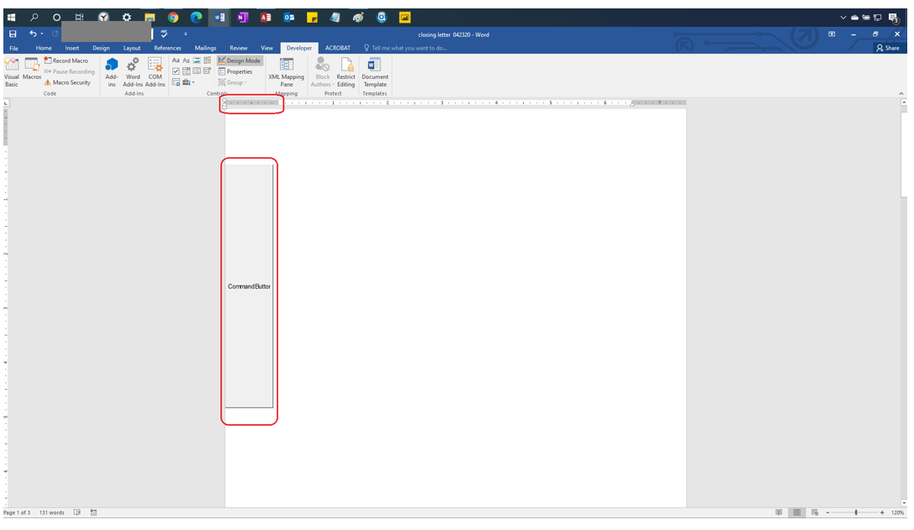

Right Click the Command Button after clicking Design Mode, in the Developer Tag and the select properties

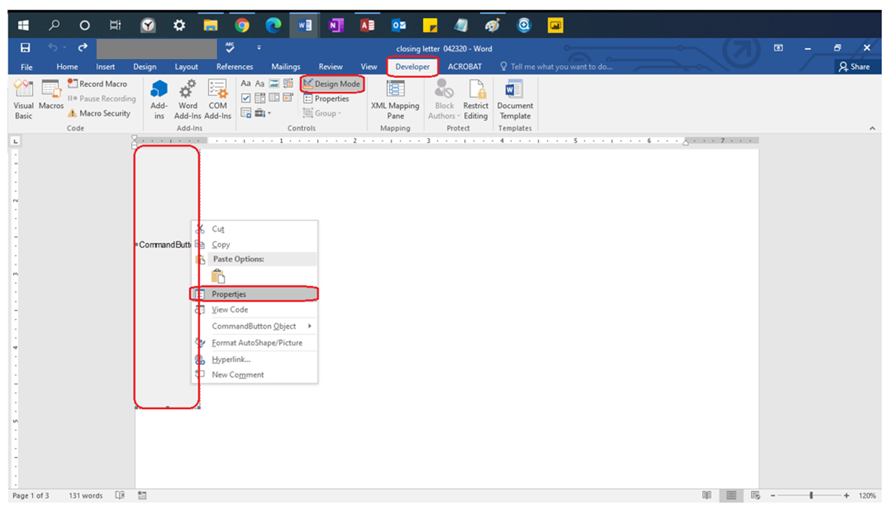

Change the name of the button from **CommandButton1** to **CommandButtonSave**

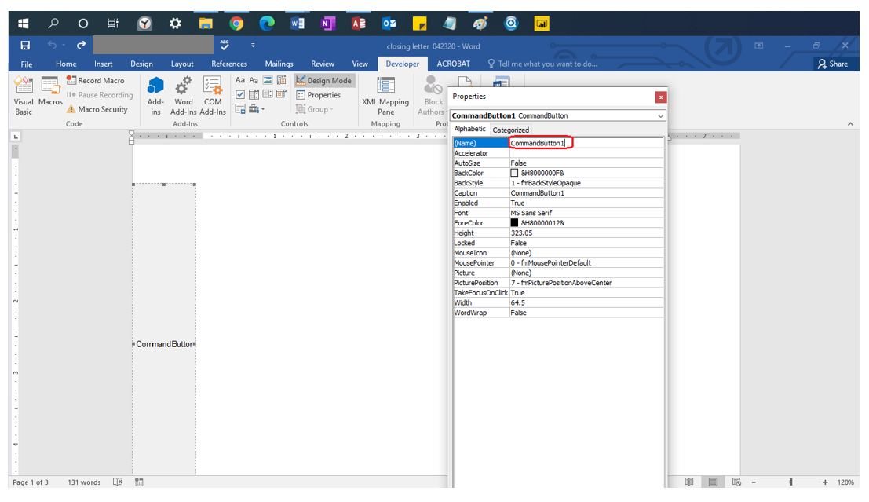

Right Click the Design View in the developer tab, then right click the button and select “View Code”

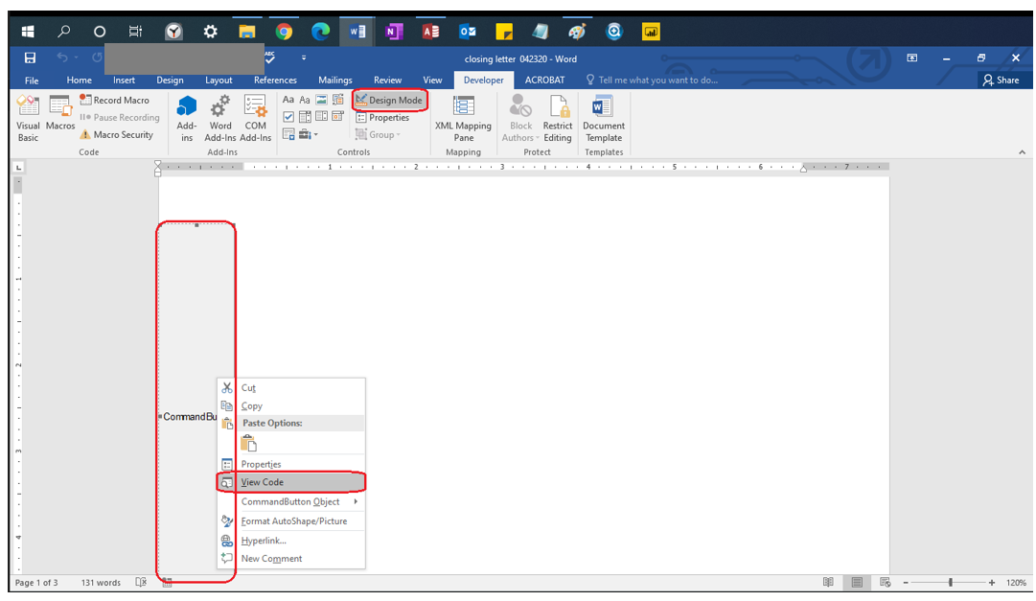

You will see the words “Private Sub” or “Public Sub” listed with a **subroutine** name (green underline) (the parenthesis are necessary), the end of the **subroutine** is the words “End Sub”. IF YOU DO NOT PASTE THE NEXT SECTION’S CODE IN BETWEEN THESE TWO LINES of Code (You can space them out by putting your cursor between them and pressing enter) IT WILL NOT WORK. DO NOT DELETE THESE LINES OF CODE. EVEN IF YOU REPLACED THE CODE WITH THE SAME VERBATIM TEXT, IT WILL NOT WORK. IF YOU DID NOT RENAME YOUR BUTTON TO CommandButtonSave IN THE PREVIOUS STEP YOUR CODE WILL NOT WORK, EVEN IF PASTED CORRECTLY.

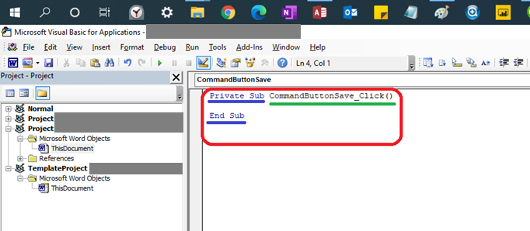

Pasting the Code

Paste the following purple text code into the Button’s Code in between the **Subroutine**’s Name and the words “End Sub” (See previous step if you’re confused about what the **subroutine** is)

[Start Code ->]

'Set Microsoft Word Object

Set WordObj = GetObject(, "Word.Application")

'Create and store variables

Dim varPCName As String

Dim varDate As String

varPCName = FormFields("FormNameTag").Result

'Test to see if the information has been imported into Access, if blank then do not save the document

If varPCName = "" Then

MsgBox "You need to import the information from Access before Saving the Document "

End

Else

ActiveDocument.FormFields("CurrentDateTag").Result = Format(Date$, "mmmm d, yyyy")

Me.CommandButtonSave.Height = 1

Me.CommandButtonSave.Width = 1

'Commented Out for Tutorial

'Selection.GoTo wdGoToPage, wdGoToAbsolute, 1

ActiveDocument.Bookmarks("\page").Range.Delete

End If

'This is for the [Censored](which is to be imported from the Access Database)

'Dim varFieldTest As String

'

'varFieldTest = ActiveDocument.FormFields("MailingAddress2").Result

'

'If varFieldTest = "" Then

'

'ActiveDocument.FormFields("MailingAddress2").Delete

'

'ActiveDocument.FormFields("MailCity").Delete

'ActiveDocument.FormFields("MailState").Delete

'ActiveDocument.FormFields("MailZip").Delete

'ActiveDocument.FormFields("Comma2").Result = ","

'

'ActiveDocument.FormFields("Comma").Delete

'

'

'End If

'Check to see if the Second Address is there, if there is no second address then delete the field box

'where the Second Address would be stored

Dim varAddressTest As String

varAddressTest = ActiveDocument.FormFields("[Censored]StreetAddressTwo").Result

If varAddressTest = "" Then

ActiveDocument.FormFields("[Censored]StreetAddressTwo").Delete

'Move the City, State and Address up by one line by

'deleting the 8th paragraph (empty paragraph that took

'the place of the second address once it was deleted)

'Commented out for tutorial

'ActiveDocument.Paragraphs(8).Range.Select

'Selection.Delete

Else

'Do nothing if the [Censored]is not empty

End If

'Get variables for the file name

varName = ActiveDocument.FormFields("[Censored]").Result

varDate = Date$

'Save the File with the variable names

WordObj.ActiveDocument.SaveAs "\\[Censored]" & varName & ", " & varDate & ".docx"

[<- End Code]

Editing the Code

Change the file path for saving the file to the Folder where you want to save your templates. This this case you need to change the red parts of the code (listed here). You can find this code by searching “WordObj.ActiveDocument.SaveAs”.

'Save the File with the variable names

WordObj.ActiveDocument.SaveAs "\\[Censored]\[Censored]\ " & varName & ", " & varDate & ".docx"

The changes are listed in blue (Change this to where you want to save your templates)

'Save the File with the variable names

WordObj.ActiveDocument.SaveAs "\\[Censored], if you add this on the network that the code is originally meant for then follow the file path to the following folders ->]\[Censored]\[Censored] " & varName & ", " & varDate & ".docx"

[Censored] Addresses

Before editing you need to save your document as a macro enabled template. Then when you want to edit the document in the future you right click the document and select open.

Click the Developer Tab, then the gray chest, then go to legacy forms and select Text Form Field. Do this a total of 10 Times (for this form). These will be the fill in areas that have data come from Access

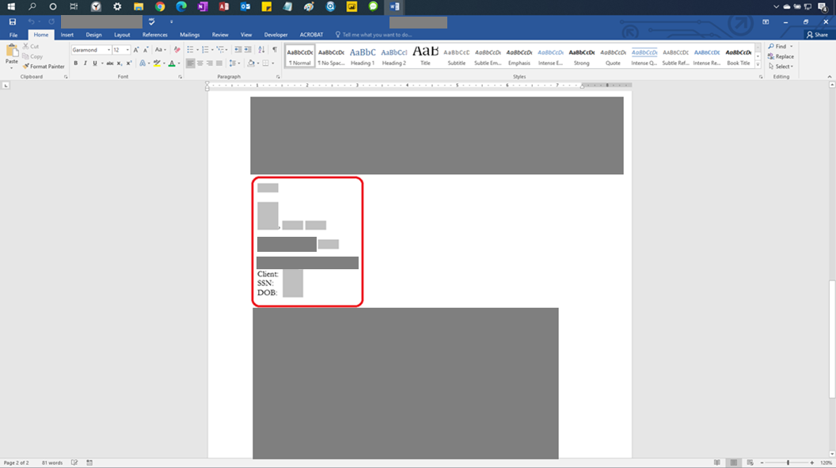

Right Click the field and select properties

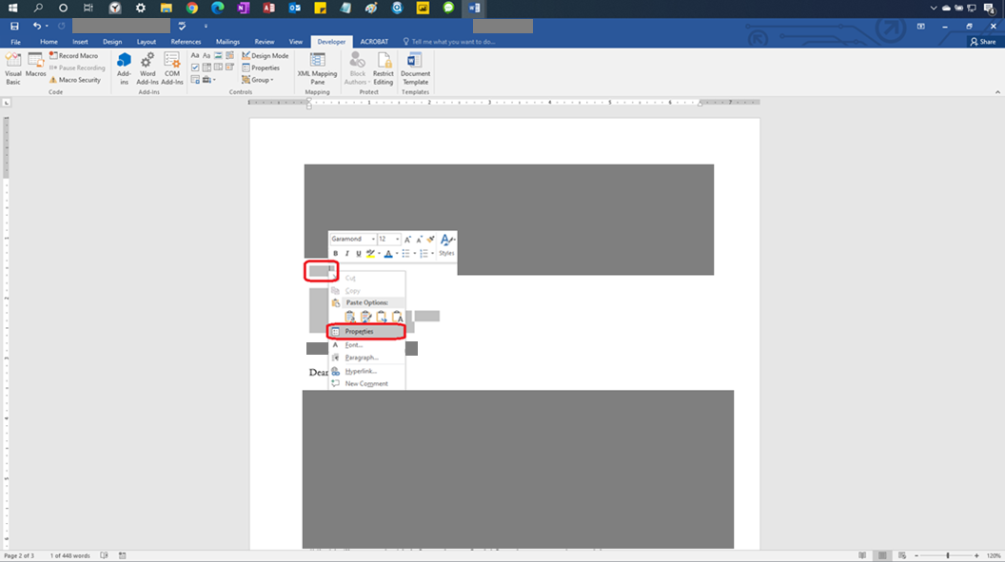

Insert the name of the Field in the blank under “Bookmark:”. This is what is referred to in the code when you try to reference that field. In this picture the field is named CurrentDateTag

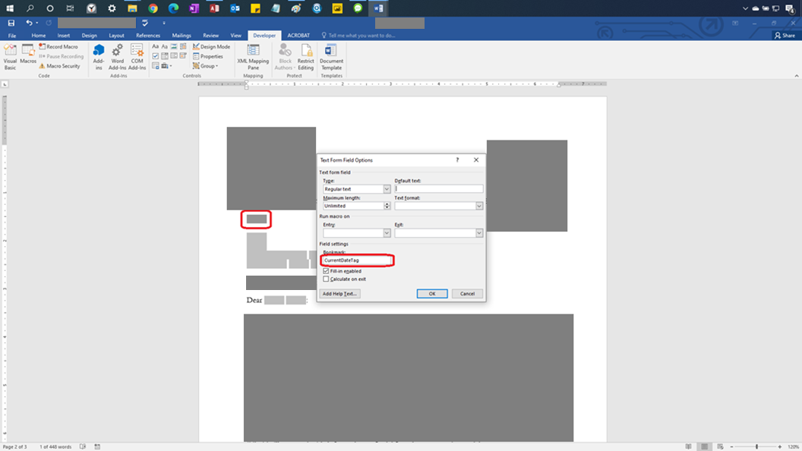

This is what the address layout of text fields looks like for a form

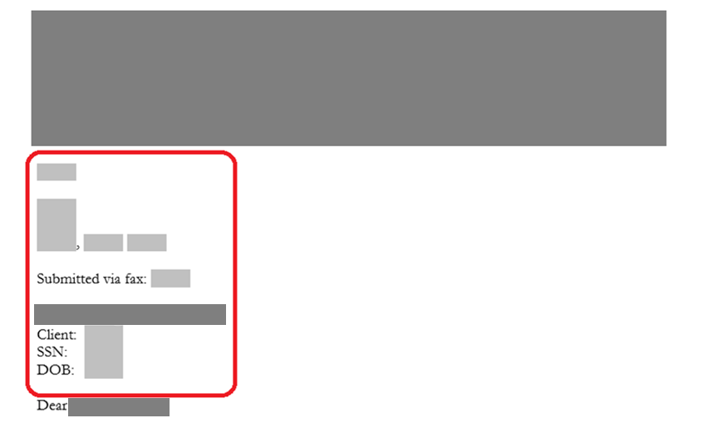

What you should name your fields (matches above picture layout):

CurrentDateTag

<Empty Row>

[Censored]AddressOne

[Censored]AddressTwo

[Censored]City,<One space> [Censored]State<One space>[Censored]Zip

[Censored]FaxNum

FormNameTag

FullFormatSSN

DOBBoxTa

Creating and Naming Button

Make sure the first page of the document is blank.

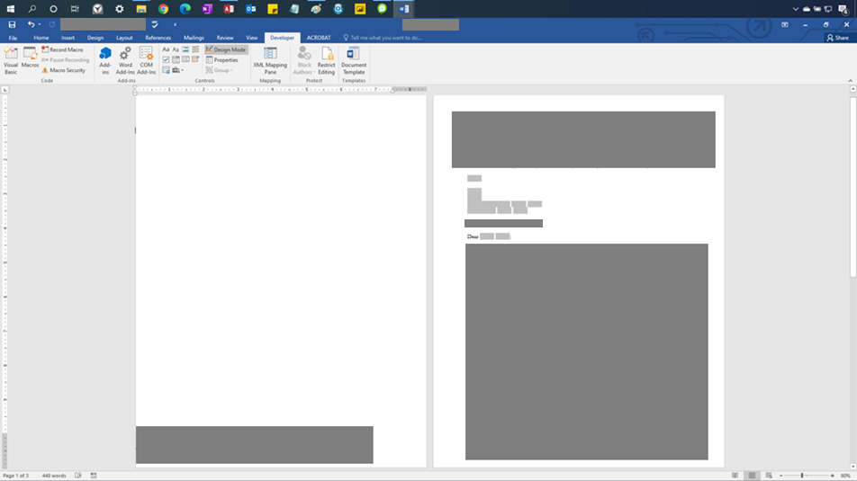

After putting your cursor in the first page, select the Developer tab. Then select the chest in the Controls group. Then select the Command Button in the Active X Controls.

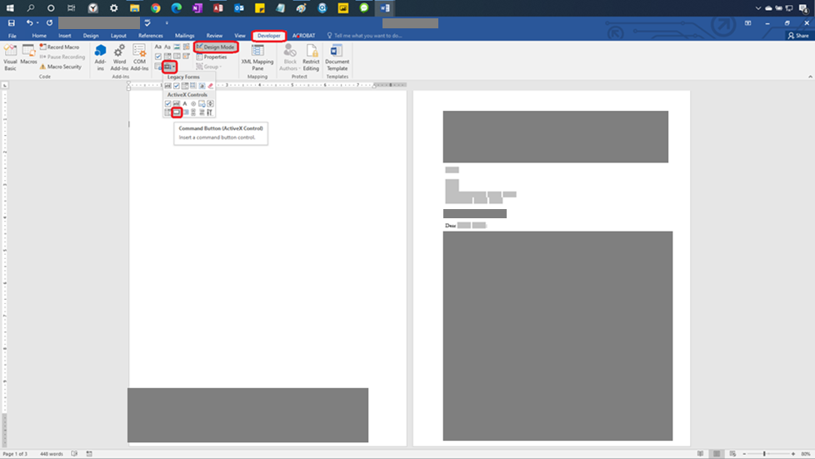

Position the button you create to be this size and in this position. The button should be completely to the left of the page margin in case it doesn’t delete properly when the code is run. If it is to the left of the page margin and it doesn’t delete it still won’t show up on the page.

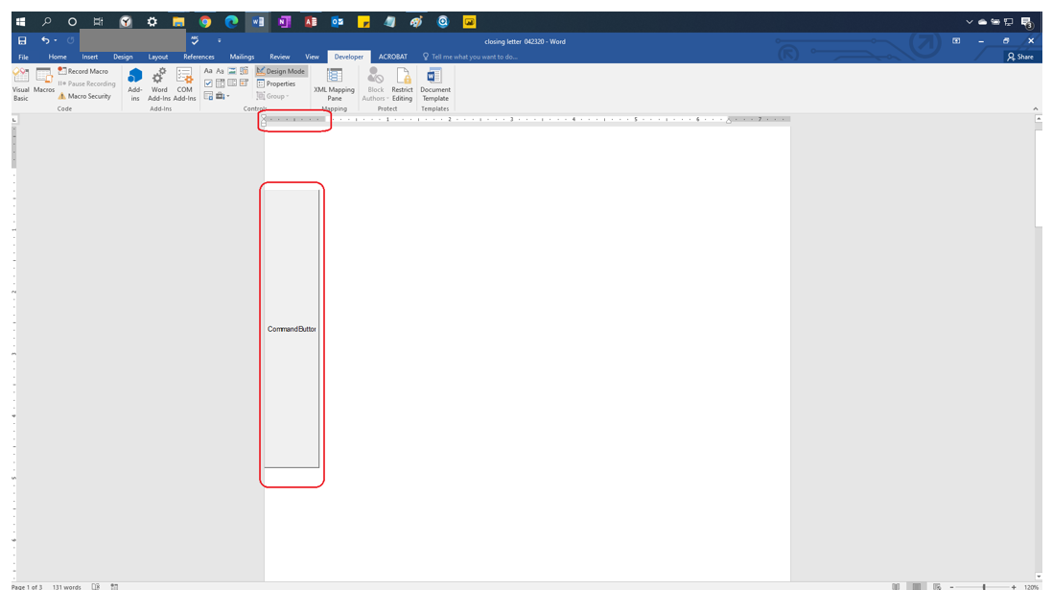

Right Click the Command Button after clicking Design Mode, in the Developer Tag and the select properties

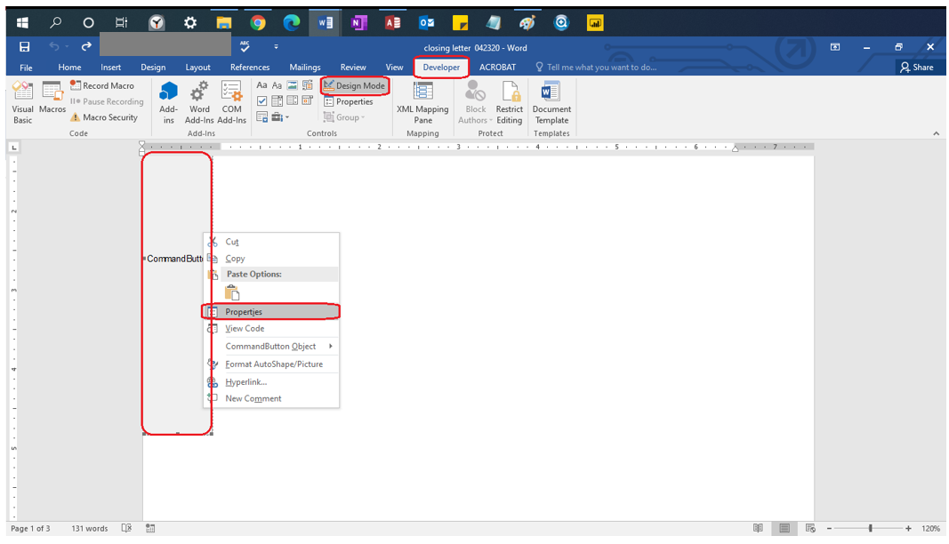

Change the name of the button from **CommandButton1** to **CommandButtonSave**

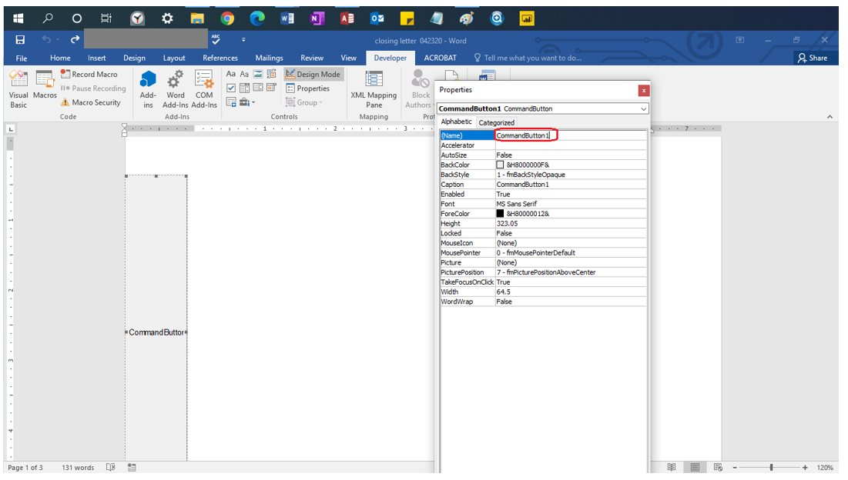

Right Click the Design View in the developer tab, then right click the button and select “View Code”

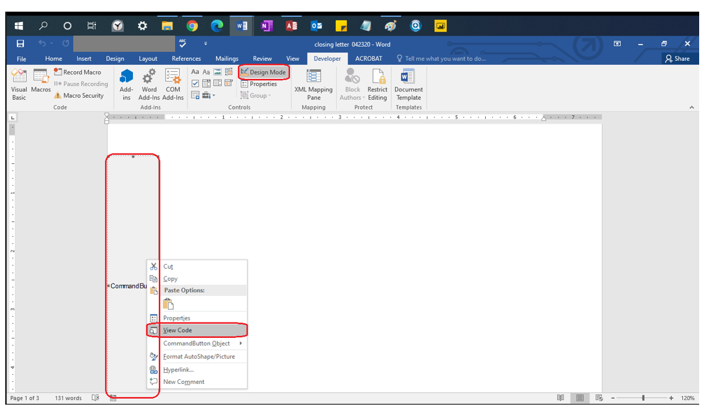

You will see the words “Private Sub” or “Public Sub” listed with a **subroutine** name (green underline) (the parenthesis are necessary), the end of the **subroutine** is the words “End Sub”. IF YOU DO NOT PASTE THE NEXT SECTION’S CODE IN BETWEEN THESE TWO LINES of Code (You can space them out by putting your cursor between them and pressing enter) IT WILL NOT WORK. DO NOT DELETE THESE LINES OF CODE. EVEN IF YOU REPLACED THE CODE WITH THE SAME VERBATIM TEXT, IT WILL NOT WORK. IF YOU DID NOT RENAME YOUR BUTTON TO CommandButtonSave IN THE PREVIOUS STEP YOUR CODE WILL NOT WORK, EVEN IF PASTED CORRECTLY.

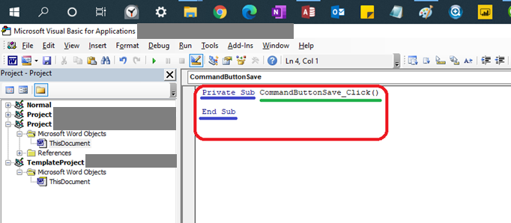

Pasting the Code

Paste the following purple text code into the Button’s Code in between the **Subroutine**’s Name and the words “End Sub” (See previous step if you’re confused about what the **subroutine** is)

[Start Code ->]

Set WordObj = GetObject(, "Word.Application")

Dim varName As String

Dim varDate As String

varPCName = FormFields("FormNameTag").Result

'Test to see if the information has been imported into Access, if blank then do not save the document

If varPCName = "" Then

MsgBox "You need to import the information from Access before Saving the Document "

End

Else

ActiveDocument.FormFields("CurrentDateTag").Result = Format(Date$, "mmmm d, yyyy")

Me.CommandButtonSave.Height = 1

Me.CommandButtonSave.Width = 1

Selection.GoTo wdGoToPage, wdGoToAbsolute, 1

ActiveDocument.Bookmarks("\page").Range.Delete

End If

'Check to see if the Second Address is there, if there is no second address then delete the field box

'where the Second Address would be stored

Dim varAddressTest As String

varAddressTest = ActiveDocument.FormFields("FOAddressTwo").Result

If varAddressTest = "" Then

ActiveDocument.FormFields("FOAddressTwo").Delete

'Move the City, State and Address up by one line by

'deleting the 7th paragraph (empty paragraph that took

'the place of the second address once it was deleted)

ActiveDocument.Paragraphs(7).Range.Select

Selection.Delete

Else

'Do nothing if the [Censored]StreetAddressTwo is not empty

End If

varName = ActiveDocument.FormFields("FormNameTag").Result

varDate = Date$

WordObj.ActiveDocument.SaveAs "\\[Censored]\Change of Address Forms\Change of Address Form, " & varName & ", " & varDate & ".docx"

[<- End Code]

Editing the Code

Change the file path for saving the file to the Folder where you want to save your templates. This this case you need to change the red parts of the code (listed here)

'Save the File with the variable names

WordObj.ActiveDocument.SaveAs "\\[Censored]\Access Template Forms\[Censored]" & varName & ", " & varDate & ".docx"

The changes are listed in blue (Change this to the file path you want to save the templates)

'Save the File with the variable names

WordObj.ActiveDocument.SaveAs "\\[Censored]\Access Template Forms\[Censored] " & varName & ", " & varDate & ".docx"

Blank Intake Forms (no auto-filling)

Before editing you need to save your document as a macro enabled template. Then when you want to edit the document in the future you right click the document and select open.

You need to add two controls to the document that you are editing. One of them will be the CurrentDateTag and the other will be the FormNameTag.

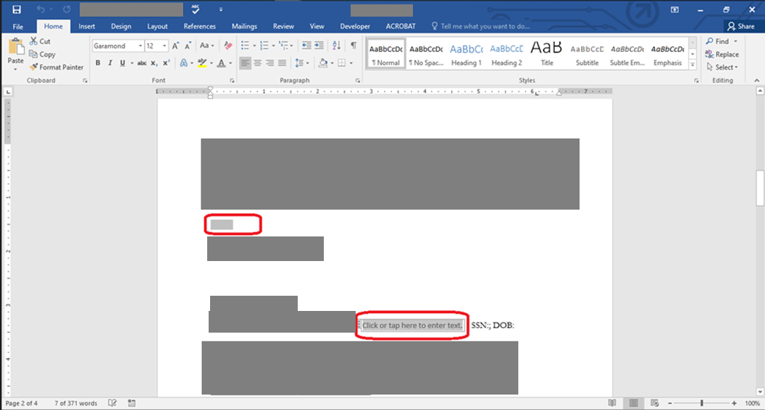

You go to this spot to add the CurrentDateTag Field. It usually goes first in your document compared to the FormNameTag.

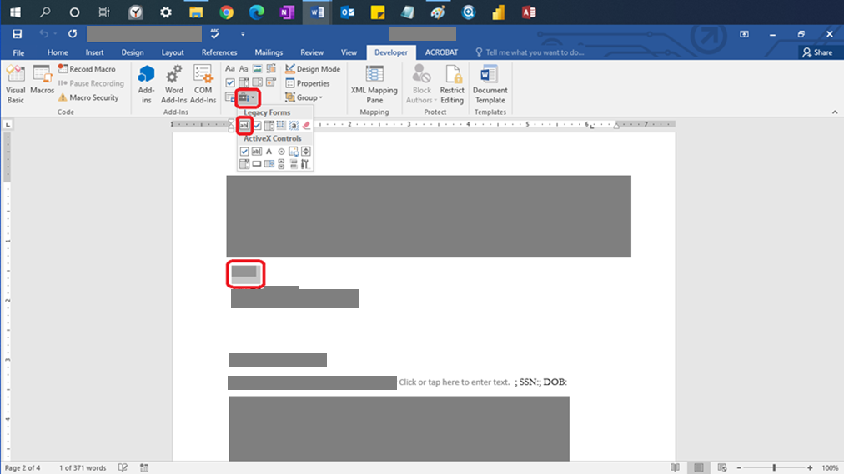

Rename this field by right clicking and selecting properties

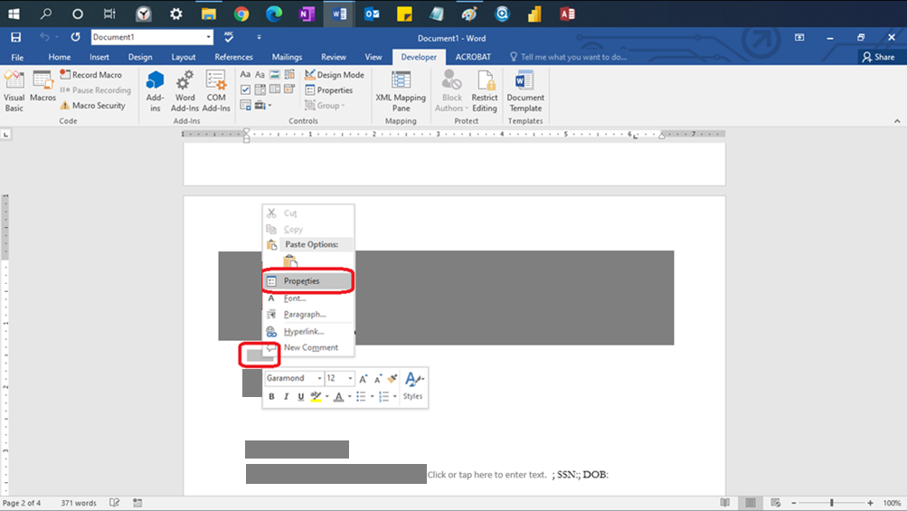

Put the name “CurrentDateTag” here when naming your Date Tag.

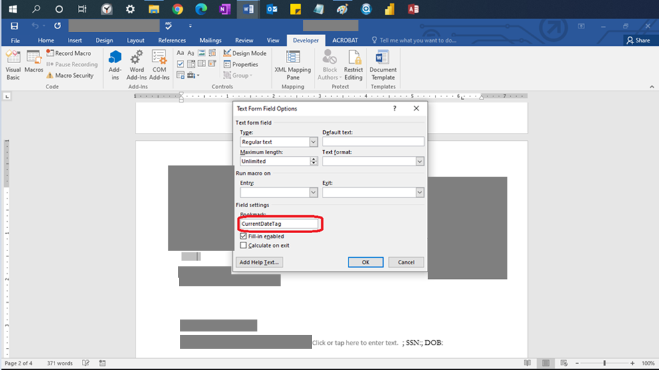

Click the button in the Developer Tab to place the Context Control needed for entering the client’s name

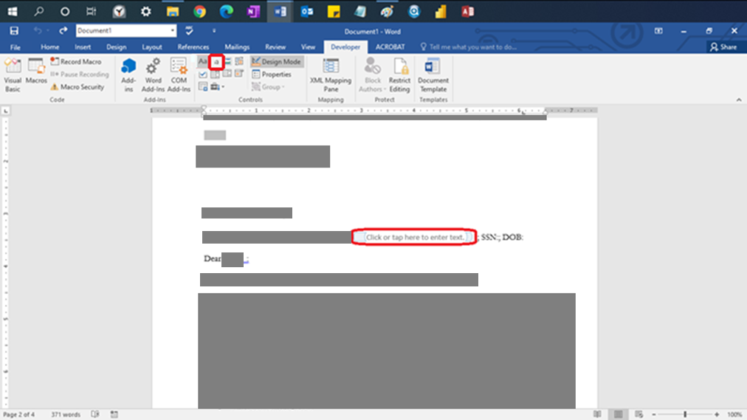

Click the Context Control, then right click and then select properties

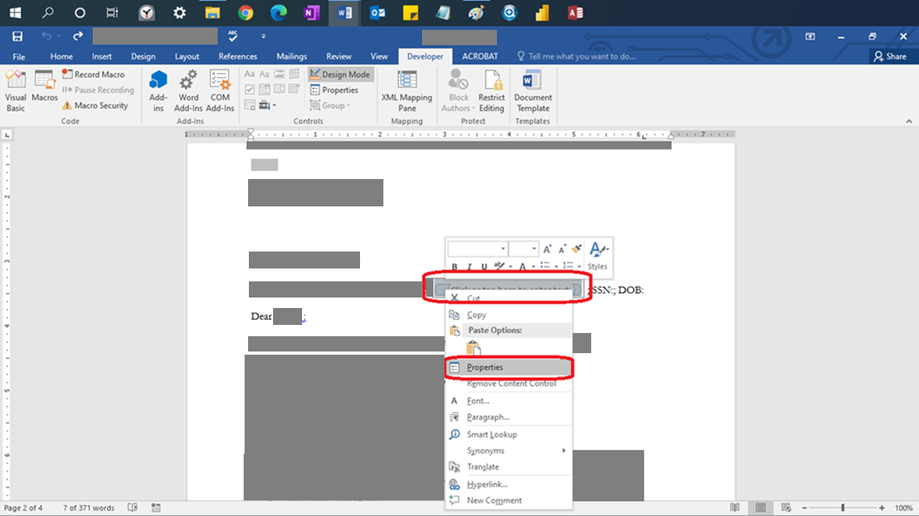

Rename the Tag to “FormNameTag” for your tag that contains the client name. This will start out as blank and will fill in when you enter their name.

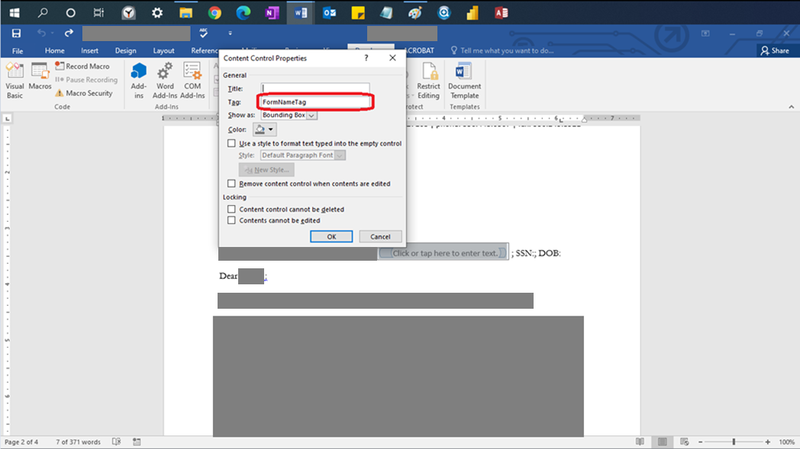

Creating and Naming Button

Make sure the first page of the document is blank.

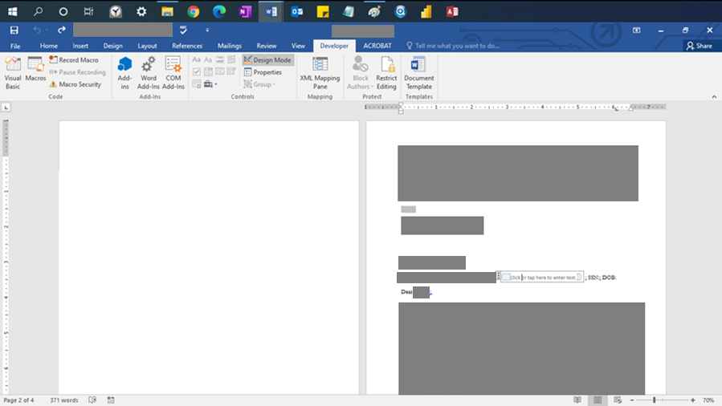

After putting your cursor in the first page, select the Developer tab. Then select the chest in the Controls group. Then select the Command Button in the Active X Controls.

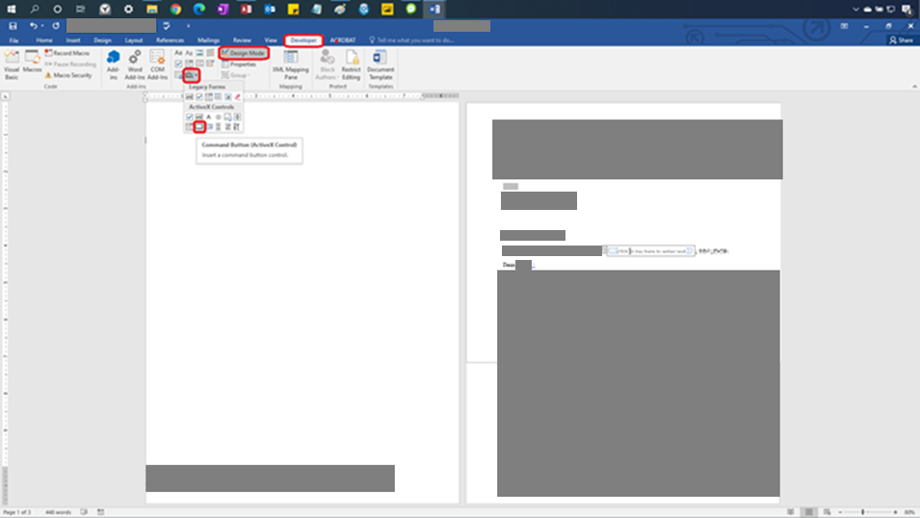

Position the button you create to be this size and in this position. The button should be completely to the left of the page margin in case it doesn’t delete properly when the code is run. If it is to the left of the page margin and it doesn’t delete it still won’t show up on the page.

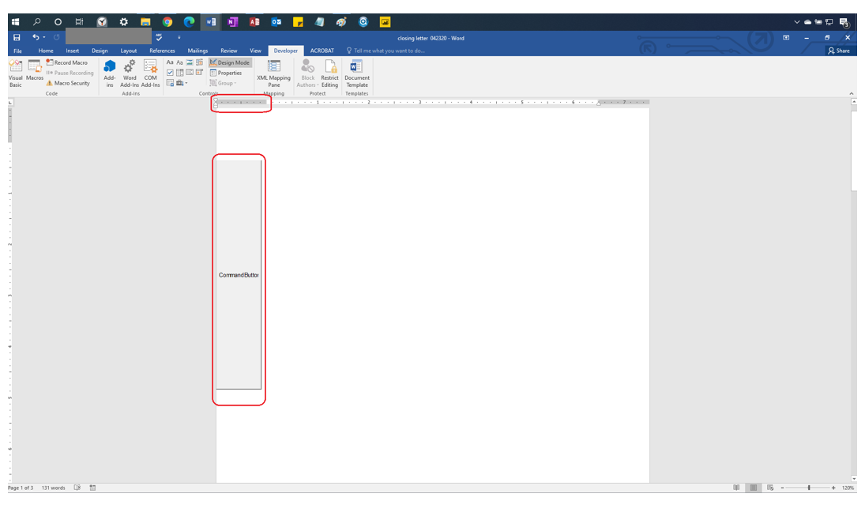

Right Click the Command Button after clicking Design Mode, in the Developer Tag and the select properties

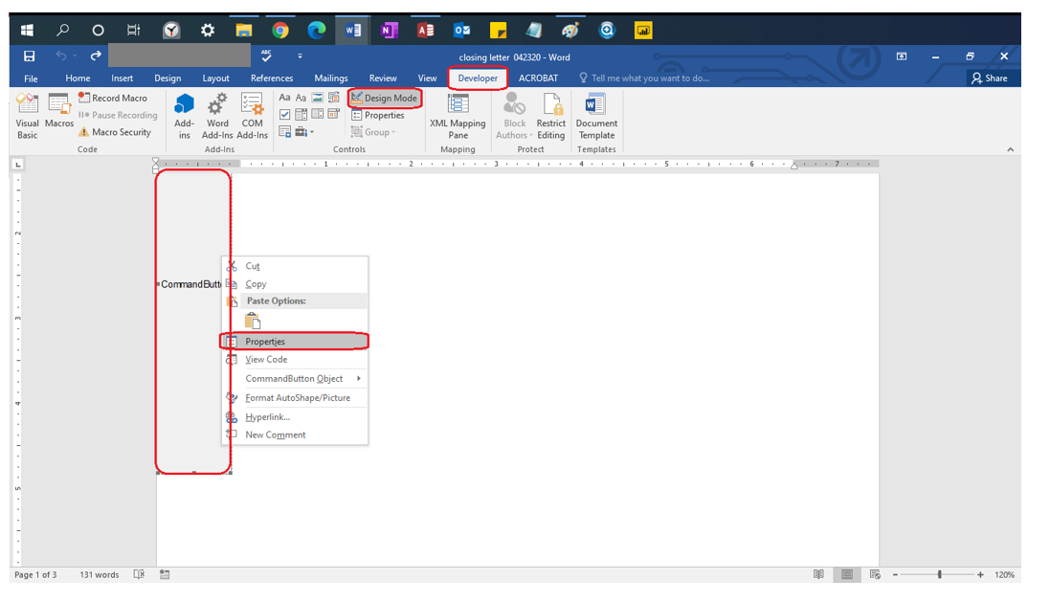

Change the name of the button from **CommandButton1** to **CommandButtonSave**

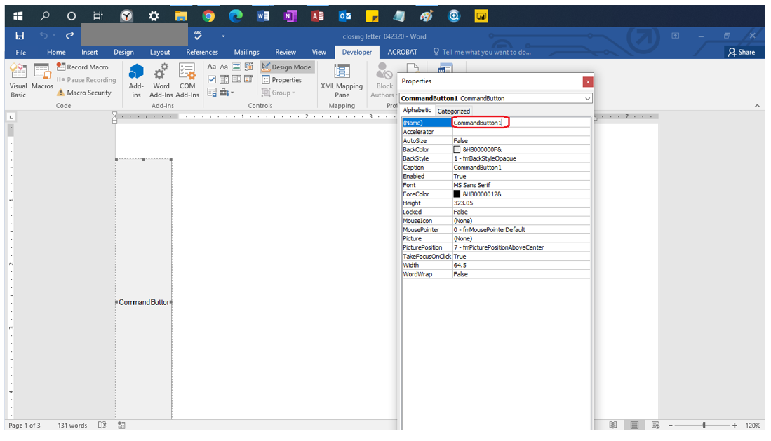

Right Click the Design View in the developer tab, then right click the button and select “View Code”

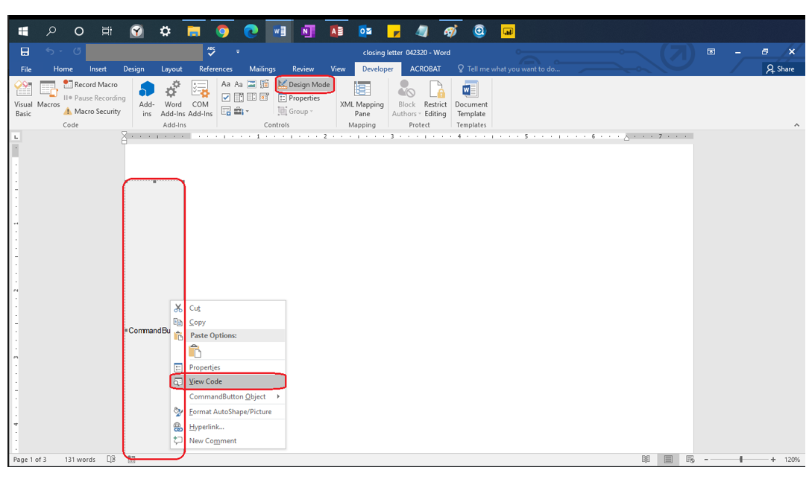

You will see the words “Private Sub” or “Public Sub” listed with a **subroutine** name (green underline) (the parenthesis are necessary), the end of the **subroutine** is the words “End Sub”. IF YOU DO NOT PASTE THE NEXT SECTION’S CODE IN BETWEEN THESE TWO LINES of Code (You can space them out by putting your cursor between them and pressing enter) IT WILL NOT WORK. DO NOT DELETE THESE LINES OF CODE. EVEN IF YOU REPLACED THE CODE WITH THE SAME VERBATIM TEXT, IT WILL NOT WORK. IF YOU DID NOT RENAME YOUR BUTTON TO CommandButtonSave IN THE PREVIOUS STEP YOUR CODE WILL NOT WORK, EVEN IF PASTED CORRECTLY.

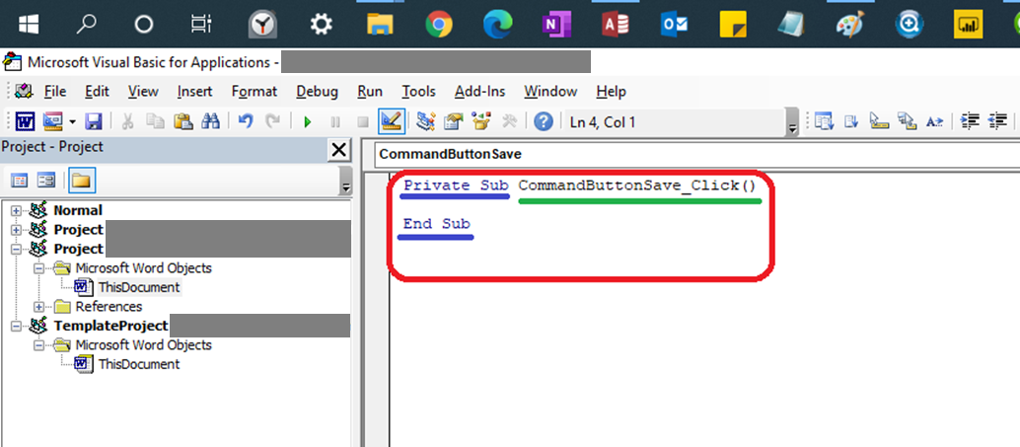

Pasting the Code

Paste the following purple text code into the Button’s Code in between the **Subroutine**’s Name and the words “End Sub” (See previous step if you’re confused about what the **subroutine** is)

[Start Code ->]

Set WordObj = GetObject(, "Word.Application")

Dim varName As String

Dim varDate As String

'Replaced by the line of code above

'ActiveDocument.FormFields("CurrentDateTag").Result = Date$

'varName = WordObj.ActiveDocument.SelectContentControlsByTag("[Censored]").Item(1).Range.Text

'varDate = WordObj.ActiveDocument.ContentControls(1).Range.Text

varName = ActiveDocument.SelectContentControlsByTag("FormNameTag").Item(1).Range.Text

'varName = ActiveDocument.FormFields("FormNameTag").Result

If varName = "Click or tap here to enter text." Then

MsgBox "Change the Name Box before clicking ""Press This Button Before Editing"" "

End

Else

End If

'Enter the Code for shrinking the button here, it needs to be after you test to see if the

'name has been entered

Me.CommandButtonSave.Height = 1

Me.CommandButtonSave.Width = 1

ActiveDocument.FormFields("CurrentDateTag").Result = Format(Date$, "mmmm d, yyyy")

varDate = Date$

WordObj.ActiveDocument.SaveAs "\\[Censored]" & varName & ", " & varDate & ".docx"

CommandButtonSave.Select

Selection.Delete

Selection.GoTo wdGoToPage, wdGoToAbsolute, 1

ActiveDocument.Bookmarks("\page").Range.Delete

[<- End Code]

Editing the Code

Change the file path for saving the file to the Folder where you want to save your templates. This this case you need to change the red parts of the code (listed here)

'Save the File with the variable names

WordObj.ActiveDocument.SaveAs "\\[Censored]\Access Template Forms\[Censored]" & varName & ", " & varDate & ".docx"

The changes are listed in blue (Change this to the file path you want to save the templates)

'Save the File with the variable names

WordObj.ActiveDocument.SaveAs "\\[Censored]\Access Template Forms\[Censored] " & varName & ", " & varDate & ".docx"

Adding Tags to Access

Open up Visual Basic in Access

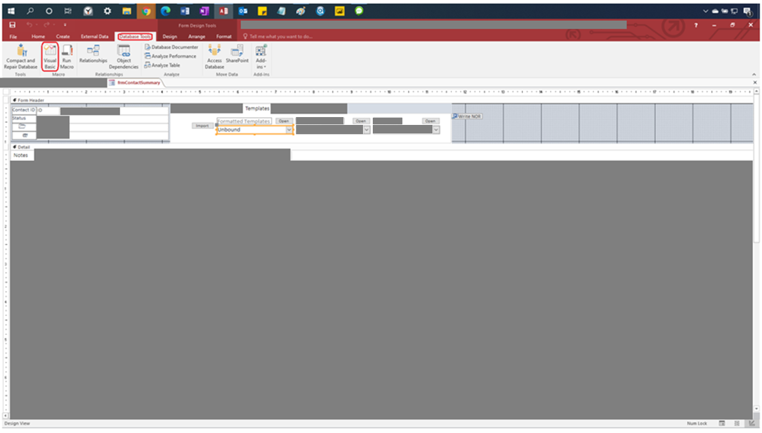

Open “Form_frmContactSummary” in the Microsoft Class Access Objects. If the window is not there, click on the “View” tab and select “Project Explorer. On your keyboard (Control-F) you can search this phrase to find the series of code you are going to insert the new tag into.

'Return to Normal Code/Code for the Access to Word Tags

Be aware of which **subroutine** you are in (PortingInfo() vs. GetFormSelected()). If you add this code to PortingInfo() you will have to add it again to GetFormSelected(). If you first add it to GetFormSelected() you will have to add it to PortingInfo() again. YOU NEED TO ADD THE SAME CODE IN BOTH PLACES. One **subroutine** is for the open button. When this method fails the other **subroutine** is with the import button. Both buttons need to work. The code is structured very similarly for both **subroutine**s and you will see repeating lines of code for both **subroutine**s.

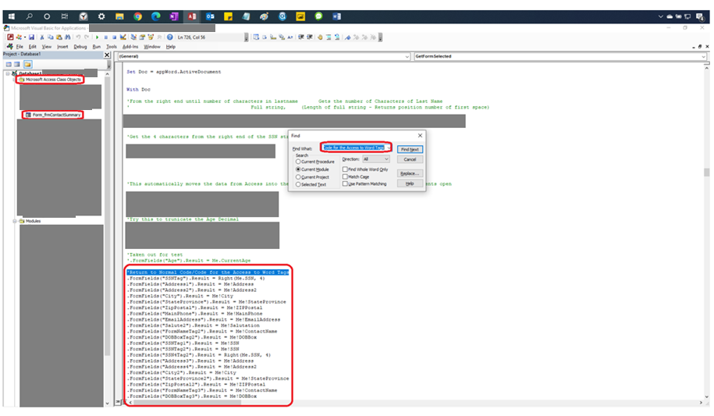

Go to where all the. FormFields are and add this code. You can just create a space between two existing lines of code.

Type:

.FormFields(“<Name for the Microsoft Word tag>”).Result = Me!<Access Field Box name to pull from>

Here’s an example of what that will look like:

.FormFields("Address1").Result = Me!Address

Here’s an example of what a subform reference looks like:

.FormFields(“Address1”).Result = Me![subform name].Form![Name of field]

Address1 is the name of the tag in Microsoft Word that you will use when you pull from the Address Box found in the Access form

Checking the Access Field’s Name

You go into design mode in Access and right click the field you want to pull information from. The name of the field will be listed in the other tab in the property sheet. If you referenced this field in the code were trying to implement, then you would reference it as

Me!txtLastNameSearch

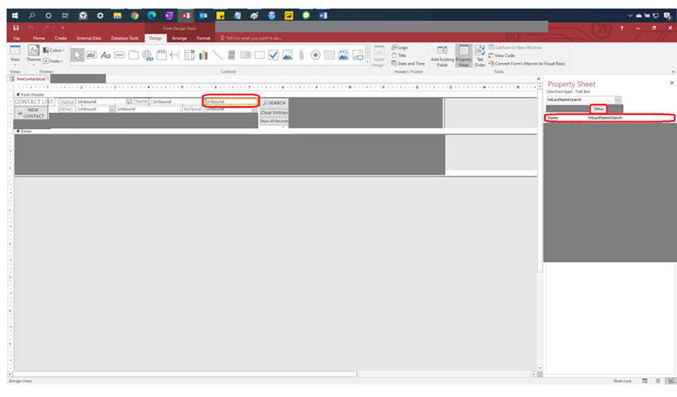

Once you’ve put the code in **subroutine** do not forget to put the exact same code in the other **subroutine** (PortingInfo() and GetFormSelected). After that if your references are correct then you’ll be able to pull from it and put it into Microsoft Word!